–––
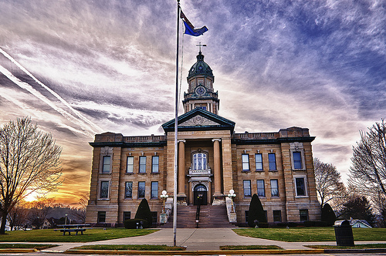
fa
Community Health Needs Assessment
2023
Lafayette County, WI

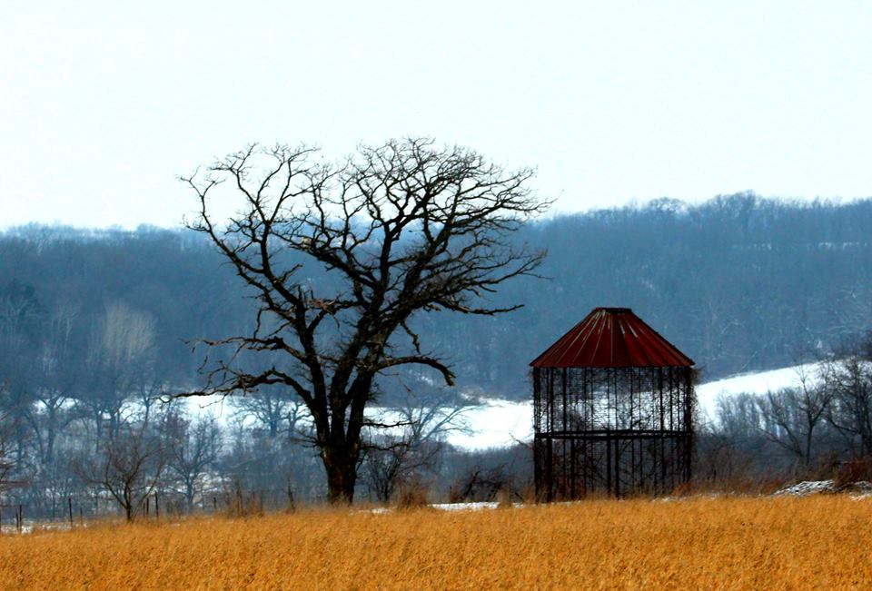

Table of Contents

Acknowledgements…………………………………………………………………...…..3

Executive Summary…………………………………………………………………...….4

Secondary Data………………….………………………………………………….….5-19
- Population Demographics……………………...………….…………....…...5-7
- Health Outcomes………………………………………………..……...………..7-8
- Health Determinants………………………………………………………..….8-9
- Chronic Disease……………………………………………………….....…..10-12
- Health Behaviors……………………………………………………………..13-14
- Social Determinants of Health……………………………………….….15-18
- Physical Environments……………………………………………….……18-19

Primary Data……………………………………………………………………...….20-36
- Stakeholder Interviews and Surveys.…………………….…………..21-25
- Community Survey…………………………………………..……..…...….26-36

Final Health Priority Ranking………………………………………...……………37

Next Steps……………………………………………………………………….………...…38

References……………………………………………………………………….…….39-40

Appendix………………………………………………………………………….……....…41

Acknowledgements

The Lafayette County Health Department would like to thank the following organizations and community leaders and members for their support and assistance in the assessment process. We are pleased to present the 2023 Lafayette County Community Health Needs Assessment on behalf of the residents of Lafayette County for individuals, agencies, and organizations to use as a basis for community health planning and intervention. We hope it serves to improve the health and wellbeing of all residents of Lafayette County.

Lafayette County Health Department Staff
Lafayette County Housing Authority
ADRC of Lafayette County
University of Wisconsin Extension Lafayette County
Southwest Regional Planning
Republican Journal, Pecatonica Valley Leader, Shopping News
Community Connections Free Clinic
Lafayette County Libraries
Southwest Wisconsin Regional Planning
Memorial Hospital of Lafayette County
Mental Health Matters of Lafayette County
Lafayette County Board of Health
Community Partners for filling out surveys and providing input
Community members for filling out surveys and providing input

Message to our Community

The Lafayette County Health Department has worked with our partners in Lafayette County on the 2023 Lafayette County Community Health Needs Assessment. We are excited to share this assessment with our partners and community members. We would like to offer our sincere gratitude to community members, partners and stakeholder who assisted us with this process.

The Community Health Needs Assessment is a process for exploring the health and needs of our county. After examining the needs determined by our stakeholders and community members we will begin to work on our Community Health Improvement Process (CHIP) to address some of the needs that were identified.

We are excited to see the work that will happen because of the Community Health Needs Assessment and Community Health Improvement Process. Working on identified priorities will require collaboration and involvement from community partners, policy-makers, clinicians, academics, employers, schools, among others. The information gathered during the assessment can be used towards making Lafayette County a healthier place to live, work, learn, and play.

Lafayette County Health Department

Secondary Data

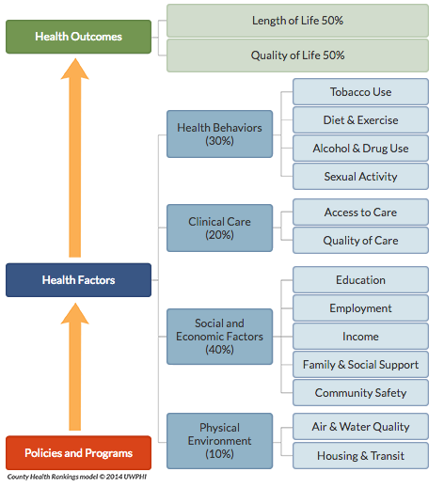
Wisconsin County Health Rankings

The County Health Rankings is an interactive ranking system of Wisconsin counties based on health care, health outcomes, health behaviors, and health determinants. The model to the right is used in the County Health Rankings, which constitutes the rational for the ranking methodology.

For the year 2022 Lafayette County ranked 38 out of 72 counties in Wisconsin for the overall ranking. Below is Lafayette County’s ranking for the individual categories.

Overall Rankings for Lafayette County (2022)
Length of Life 39
Quality of Life 38
Health factors 55
Health behaviors 56
Clinical care 71
Social & Economic 23
Physical Environment 57

The following population statistics are based on the Wisconsin County Health Rankings and other nationally accumulated data sources. The 2022 Lafayette County Snapshot is available in the Appendix.

Population Demographics
2020 Census | Lafayette Percent | WI Percent
White | 91.69% | 80.38%
Black or African American | 0.17% | 6.38%
American Indian | 0.29% | 1.03%
Asian | 0.24% | 2.98%
Some other race | 3.70% | 3.09%
Total Population (2020) = 16,611

Age:
Gender:

Age Category (2021) | Lafayette Population Estimate | Percent of the Population
Under 5 years | 1,054 | 6.3%
5 to 9 years | 1,188 | 7.1%
10 to 14 years | 1,052 | 6.3%
15 to 19 years | 1,138 | 6.8%
20 to 24 years | 879 | 5.3%
25 to 34 years | 1,831 | 11.0%  Race:
35 to 44 years | 1,853 | 11.1%
45 to 54 years | 1,944 | 11.7%
55 to 59 years | 1,330 | 8.0%
60 to 64 years | 1,251 | 7.5%
65 to 74 years | 1,773 | 10.6%
75 to 84 years | 959 | 5.8%
85 years and over | 410 | 2.5%
2021 | Estimate
Male | 8,469
Female | 8,193

As of 2020, 6.6% of Lafayette County residents are estimated to be Hispanic regardless of race.

Population over selected years categorized by age:
Age | 2016 | 2017 | 2018 | 2019 | 2020 | 2021
Under 18 years | 24.7% | 24.8% | 24.7% | 24.4% | 24.2% | 24.4%
Under 5 years | 6.5% | 6.5% | 6.5% | 6.3% | 6.4% | 6.3%
5 to 14 years | 14.0% | 13.9% | 13.7% | 13.6% | 13.3% | 13.4%
15 to 17 years | 4.3% | 4.5% | 4.5% | 4.5% | 4.5% | 4.6%
18 to 64 years | 58.4% | 58.0% | 57.7% | 57.5% | 56.9% | 56.8%
18 to 24 years | 7.7% | 7.4% | 7.5% | 7.4% | 7.5% | 7.5%
25 to 44 years | 21.7% | 21.8% | 21.8% | 22.0% | 21.8% | 22.1%
45 to 64 years | 29.0% | 28.9% | 28.4% | 28.1% | 27.6% | 27.2%
65 years and over | 16.9% | 17.1% | 17.6% | 18.2% | 18.9% | 18.9%
85 years and over | 2.6% | 2.7% | 2.9% | 2.8% | 2.8% | 2.5%
Source: US Census Bureau, ACS Demographic Estimates, 5-year Estimates, 2016-2020 https://data.census.gov/

Population Density:
In 2020, there were 26.2 persons per square mile in Lafayette, which is considerably less compared to Wisconsin’s average of 108.8 people per square mile (US Census Bureau, 2020). Lafayette County is considered completely rural. There are no metropolitan or micropolitan classified areas within the county.
Source: US Census Bureau, Data.Census.gov

Health Outcomes
Premature Death:
Premature death calculates the years of potential life lost before age 75 per 100,000 population (age-adjusted). Deaths occurring before the age of 75 contribute to the total years of potential life lost. This is a measure of premature mortality focusing on preventable deaths.
- 6,519 are the number of years of potential life lost calculated for Lafayette County (The target value is 5,200).
- Lafayette County is slightly below the Wisconsin average of 6,600 years
- This value has been trending down since 2009 for Lafayette.
Source: 2022 County Health Rankings

Low Birth Weight:
The County Health Rankings evaluate low birth weight, as it is an indicator of multiple factors. It represents maternal exposure to health risks and the infant’s current and future risk of morbidity, as well as premature mortality risk.
- The percentage of live births with low birth weight (<2500 grams) was 5.9% in Lafayette County. (The target value is 5.9%).
- Lafayette County performs better than the Wisconsin average of 8%.
Source: 2022 County Health Rankings

The following health outcome measures use data presented by the 2022 County Health Rankings. The data is age-adjusted from the Behavioral Risk Factor Surveillance System based on 2019 data.

General Health Status:
Self-reported health status is a widely used measure of people’s health-related quality of life. The Behavioral Risk Factor Survey asks people to rate their health as excellent, very good, good, fair, or poor.
- Percentage of adults reporting fair or poor health in Lafayette County was 15.9%.
- This is a deterioration from 2015, which showed 12% of people reported fair or poor health.

Poor Physical Health Days:
The measure of poor physical health days is based on responses to the question: “Thinking about your physical health, which includes physical illness and injury, for how many days during the past 30 days was your physical health not good?”
- The average number of physically unhealthy days was 3.8 in Lafayette County.
- This was slightly worse than the number of Wisconsin poor health days of 3.6 but better than the National average of 3.9 poor health days.

Poor Mental Health Days:
- The average number of poor mental health days reported by members of Lafayette County was 4.6.
- This was slightly worse than the number of Wisconsin poor mental health days of 4.4 and the National average of 4.5 poor mental health days.
- The average number of poor mental health days has increased from 2.2 days reported in the 2015 community health assessment.

Health Determinants

Health Care
Lafayette County does rather poor when it comes to health care, receiving an overall ranking of 71 out of 72 in the area of clinical care for the 2022 County Health Rankings.

Health Insurance coverage:
Lack of health insurance coverage is a barrier to accessing health care services. Uninsured adults under the age of 65 are represented in the percentage, based on 2019 data.
- Lafayette County has 12% of the adult population uninsured. This is an improvement from the 14% uninsured rate in the 2015 community health assessment.
- Lafayette County’s uninsured rate is well above the Wisconsin average of 7% and National average of 11%.
- Since 2015 the Wisconsin and National rates have remained the same, but the Lafayette County rate has increased. However Lafayette’s uninsured rate has still fallen from before pre-2015 rates.
Source: 2022 County Health Rankings

Medicaid Recipients:
Below are the reports for those residents in Lafayette County currently enrolled in BadgerCare.
The number of residents enrolled in BadgerCare continues to steadily increase over the last 6 months continuing this longer term trend.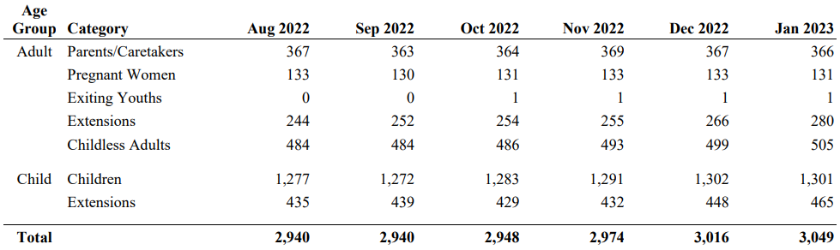
Source: Wisconsin Department of Health Services. BadgerCare Plus. https://dhs.wisconsin.gov/badgercareplus/enrolldata.htm

Primary Care Provider Rate:
Access to care involves not only financial access to insurance, but also physical access to providers. The measure is a ratio of the population to total primary care physicians. It should be noted this measure does not include physician assistants or nurse practitioners, which are critical members of the Lafayette County Memorial Hospital health care team.
- Lafayette County’s current ratio is 4,166: 1 based on 2020 data.
- This is much higher than the State’s ratio of 1,260:1 and National average of 1,310:1.
Source: 2022 County Health Rankings

Preventable Hospital Stays:
The measure represents the number of hospital stays that might have been prevented by outpatient treatment for ambulatory-care sensitive conditions per 100,000 Medicare enrollees.
- There were 4,472 preventable hospital stays per 100,000 in Lafayette based on 2019 data.
- Lafayette used to perform better than Wisconsin and the Nation from 2015-16, but has been slowly deteriorating and now performs worse than both the Wisconsin rate (3,260 per 100,000 Medicare enrollees) and the National rate (3,767 per 100,000 Medicare enrollees).
Source: 2022 County Health Rankings

Oral Health:
Untreated dental conditions can lead to serious health complications. Having access to dentists is one barrier in receiving care.
- The ratio of Lafayette County population to dentist is 4,160:1 based on 2020 data.
- While ratio of the population to dentists has been slowly decreasing over the last 10 years in Wisconsin and the Nation, the ratio in Lafayette has remained mostly unchanged from the ratio of 4200:1 in 2014.
Source: 2022 County Health Rankings

Mammography Screening:
Breast cancer is the second most common cancer among women and is very cost intensive. Mammography screening leads to earlier diagnosis and reduces mortality. The percentage of female Medicare enrollees’ ages 65-74 who received a mammography screening based on 2019 data was the measure used by the 2022 County Health Rankings.
- 43% of women in Lafayette of the analyzed age reported receiving a mammography.
- Lafayette performs the same as the National average, and slightly behind Wisconsin’s rate of 49%
Source: 2022 County Health Rankings

Note: This statistic may be affected by the United States Preventive Services Task force recommendation that women who are 50-74 years old and are at average risk for breast cancer get a mammogram every two years.
Source: United States Preventive Services Task Force

Chronic Disease
Asthma:
Asthma affects people of all ages, but often starts in childhood. It may be caused by a genetic component as well as early exposure to second hand smoke, infections, and allergens. Exposure to air pollution, tobacco smoke, or pollen can trigger an asthma attack.
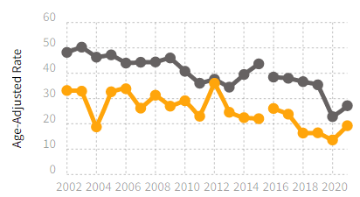
- In 2021, 19.27 Emergency Room visits per 10,000 (age-adjusted) were asthma related in Lafayette County.
- The state age adjusted rate was 27.17 in 2021.
- The graph to the right shows the rate of Emergency Room visits related to asthma from 2002-2021 in Lafayette County compared to Wisconsin.
Sources: Wisconsin Department of Health Services, Environmental Public Health Data Tracker.
*On October 1st, 2015, there was a change in how hospitalization and emergency department data are coded, which is why there is a break in the line chart
= Wisconsin
= Lafayette County

https://dhsgis.wi.gov/DHS/EPHTracker
/#/all/Asthma/asthmaIndex/NOTRACT
/Emergency%20Department%20Visits

Diabetes:
- The of Lafayette County residents aged 20+ years who have ever been told they have diabetes was 8% in 2020, increased from 7.2% in 2015, and continuing a trend from 6.3% in 2004.
- Wisconsin’s rate of diabetes for residents aged 18+ years was 7.6% in 2020, increased slightly from up from 5.5% in 2004.
- Both Lafayette County and Wisconsin’s increase coincide with National trends during the same time frame. The National rate of adults aged 18+ went from 7% in 2004 up to 8.2% in 2020 (CDC)

Heart Disease:
Heart disease is the leading cause of death in Wisconsin in 2020 and the number two cause of death in Lafayette County in 2020 (WDHS, 2023). Chronic heart disease has been shown to both decrease quality of life and increase medical costs. Some types of heart disease are due to genetics. There are many risk factors for heart disease that can be affected by an individual’s health behaviors.
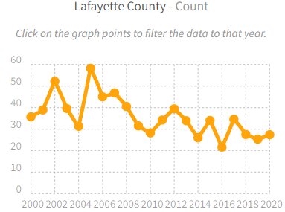
Number of hospitalization for heart attack of
- The age-adjusted rate of hospitalizations for heart attacks among persons 35 and over per 10,000 people in Lafayette County was 25.3 in 2020.
- The number of hospitalizations for heart attacks in Lafayette has been generally declining since 2000. Refer to the graph on the left.
Source: Wisconsin Environmental Public Health Data Tracker, https://dhsgis.wi.gov/DHS/EPHTracker/#/report

people 35 years and older in Lafayette County.
Number of Hospitalizations in Lafayette County (2017)
 | Age Category
Disease Condition | <18 | 18-44 | 45-64 | 65+ | Total
Injury-Related (All) | 11 | 28 | 30 | 65 | 134
- Hip Fractures | -- | -- | -- | 18 | 20
- Poisonings | -- | 0 | -- | -- | 7
Mental Disorders | 11 | 17 | 11 | 13 | 52
Coronary Heart Disease | -- | - | 21 | 32 | 57
Cancer (All) | -- | 3 | 19 | 35 | 57
- Female Breast Cancer | -- | -- | -- | -- | 0
- Colo-rectal | -- | -- | -- | 6 | 9
- Lung | -- | -- | -- | -- | 2
Diabetes | -- | -- | -- | 0 | 6
Alcohol-Related | -- | 4 | 5 | -- | 10
Drug-Related | -- | 1 | -- | -- | 1
Pneumonia & Influenza | 3 | -- | 10 | 47 | 63
Cerebrovascular Disease | -- | -- | 5 | 36 | 41
Asthma | 3 | 0 | 3 | 0 | 6
Chronic Obstructive Pulmonary Disease | -- | -- | 10 | 20 | 30
Total Hospitalizations | 201 | 238 | 230 | 502 | 1171
Preventable Hospitalizations | 10 | 16 | 53 | 131 | 210
Specific disease conditions were analyzed to determine the number of admissions based on condition. According to the data provided Injury- related conditions and Pneumonia and Influenza were the top two reasons for hospitalization. All possible reasons for hospital admission were not included in the data.
Source: Wisconsin Department of Health Services, Public Health Profiles 2017, https://dhs.wisconsin.gov/publications/p4/p45358-2017-lafayette.pdf
Cancer:
Cancer may start anywhere in the body when abnormal cells grow out of control and crowd out normal cells. Cancer is a complex disease caused by multiple factors such as, tobacco use, diet, exercise, genetic factors, environmental exposure to chemicals and radiation, and certain types of infections. According to the American Cancer Society, approximately 1 in every 2 males and 1 in every 3 females in the US will develop some type of cancer in his/her lifetime (ACS, 2023). The table below outlines the incidence of cancer and deaths attributed to cancer in Lafayette County.

Cancer Incidence and Mortality, 2015-2019

 | Lafayette County Incidence |  | Wisconsin Incidence | Lafayette County Mortality*
 | Total Cases | Average Rate | Average Rate | Total Deaths | Average Rate
All Cases | 538 | 488 | 468.2 | 201 | 167.1
Breast (Female) | 85 | 86.3 | 127.2 | 12 | 10.1
Colon/Rectum | 39 | 37.7 | 39.1 | 18 | 14.5
Kidney & Renal Pelvis | 25 | 22.1 | 19.0 | X | X
Leukemia | 18 | 17.4 | 16.5 | 10 | 8.8
Lung | 53 | 42.0 | 58.6 | 39 | 31.3
Myeloma | 11 | 12.1 | 7.1 | X | X
Non-Hodgkin Lymphoma | 25 | 21.3 | 21.1 | X | X
Oral Cavity & Pharynx | 22 | 19.4 | 12.5 | X | X
Ovary | 7 | 7.9 | 5.6 | X | X
Pancreas | 15 | 12.1 | 13.8 | 15 | 13.1
Prostate | 68 | 54.1 | 55.9 | 13 | 10.2
Skin (melanoma) | 24 | 22.5 | 24.2 | X | X
Thyroid | 15 | 18.2 | 13.6 | X | X
Urinary Bladder | 25 | 19.7 | 22.3 | X | X
Uterine | 16 | 14.2 | 16.5 | X | X
*An “X” indicates that the value is less than 10 but more than zero, and has been marked this way to protect confidentiality.
Incidence refers to the total number of new cases within the specified time period. Average rates are age-adjusted rate per 100,000 population. Wisconsin incidence average rate was included as a comparison to Lafayette County cancer incidence.
Source: American Cancer Society, 2023, https://www.cancer.org/healthy/cancer-causes/general-info/lifetime-probability-of-developing-or-dying-from-cancer.html

Health Behaviors
The type of health behaviors individuals partake in can affect their health. Poor diet, being overweight or obese, physical inactivity, use of tobacco or alcohol, and engaging in risky sexual behaviors can lead to the development of chronic health conditions, such as heart disease, stroke, diabetes, or cancer (Spring, et. al., 2012). Looking at Lafayette County’s health behaviors provides insight into the county’s health and the possible trajectory of future medical concerns.
Overweight and Obesity:
- Wisconsin has the 29th highest adult obesity rate of the 54 states and US territories in the nation (CDC, 2021).
- Based on 2019 data, 37% of Lafayette County residents reported being obese (a BMI of 30 or higher). This continues to trend upwards.
- Lafayette has a higher percentage of obesity compared to the sate’s average of 34%. The state’s average also continues to trend upward.
Source: 2022 County Health Rankings
Physical Activity:
Engaging in physical activity on a regular basis can decrease one’s risk of cardiovascular disease, type 2 diabetes, and metabolic syndrome. In addition regular physical activity can reduce one’s risk of dying early (CDC, 2023).
- 24.9% of people in Lafayette County aged 18 and older reported no leisure time physical activity based on data from 2019.
- Lafayette performs worse than the state average of 22%.
- In comparison only 32% of Lafayette County resident have access to exercise opportunities, compared to the states average of 78%.
Source: 2022 County Health Rankings; CDC, Division of Nutrition, Physical Activity, and Obesity, https://www.cdc.gov/physicalactivity/basics/pa-health/
Diet:
- 8.8% of Lafayette County residents are food insecure. Wisconsin’s average is 9.1%.
- 4% of Lafayette County residents have limited access to healthy foods. Wisconsin’s average is 5%.
- Based on the above measures the County Health Rankings provides a food environment index score using a scale of 0 (worst) to 10 (best). Lafayette has an index score of 8.7, which suggests the food environment is relatively good for residents, and is on par with the state’s food environment index of 8.7
Source: 2022 County Health Rankings
Tobacco:
The effects of tobacco, specifically smoking, have been extensively studied. Smoking is directly related to deaths caused by respiratory disease, lung cancer, and cardiovascular disease. There is also a hefty financial cost associated with smoking. In 2018 the nation, spent $240 billion in healthcare spending related to cigarette smoking (CDC).
- 19% of Lafayette County adults smoke according to 2019 data.
- This was higher than Wisconsin’s average of 16% of adult smokers in 2019.
- Only 5% of Wisconsin high school students reported currently smoke cigarettes.
- 11% of Wisconsin high school students report currently using electronic vapor products and 24% report having ever used electronic vapor products.
Source: 2022 County Health Rankings; CDC 2021 Youth Risk Behavior Survey https://nccd.cdc.gov/Youthonline/App/Default.aspx
Alcohol Use:
Excessive drinking is a risk factor for adverse health effects, such as sexually transmitted infections, hypertension, acute myocardial infarction, unintended pregnancy, fetal alcohol poisoning, motor vehicle accidents, and interpersonal violence (CDC, 2016). From 2015-2019 excessive alcohol consumption caused 12.9% of total deaths across the nation, and 14.2% in Wisconsin (JAMA, 2022).
- According to 2019 data 25% of Lafayette County residents report binge or heavy drinking, matching Wisconsin’s average, but worse than the nation rate 20%.
- Lafayette has seen an increase in binge drinking from the 2015 community health assessment, which reported 18%.
- In Lafayette 50% of driving deaths involved alcohol. Wisconsin’s average is 39%, whereas the US top performers only had alcohol involved in 14% of driving deaths.
- Significant public health benefits could be achieved by lowering the amount of binge drinking and driving while intoxicated by county residents.
Source: 2022 County Health Rankings; CDC, Alcohol-Related Disease Impact, 2015-2019, https://nccd.cdc.gov/DPH_ARDI/default/default.aspx; Jama Network, Estimated Deaths Attributable to Excessive Alcohol Use Among US Adults Aged 20 to 64 Years, 2015 to 2019. https://jamanetwork.com/journals/jamanetworkopen/fullarticle/2798004

Sexually Transmitted Disease:
- According to 2019 data, the rate of newly diagnosed chlamydia cases, in Lafayette County per 100,000 was 204, up from the rate of 125 based on 2012 data.
- This is well below Wisconsin’s average rate of 499, but Lafayette has been trending up since 2010.
- Of note, this rate only includes chlamydia. Chlamydia is the most common STI in North America, according to the 2022 County Health Rankings.
Source: 2022 County Health Rankings

Violent Crime:
Violent crime is defined as face-to-face confrontation between victim and perpetrator, such as homicide, forcible rape, robbery, and aggravated assault. A safe physical environment is necessary to promote positive health behaviors like exercising outdoors.
- Data from 2014-2016 shows, Lafayette has a rate of 90 violent crime offenses per 100,000.
- Lafayette ranks 23rd with for lowest violent crime rate in Wisconsin.
- This is worse than from the rate reported in the 2015 community health assessment, 28.
- Wisconsin’s current average is 298 per 100,000.
Source: 2022 County Health Rankings

Social Determinants of Health
More than health status or health behaviors impact health. The World Health Organization (WHO) defines social determinants of health as “the conditions in which people are born, grow, work, live, and age.” A person’s level of education, employment status, income, and home life can impact their health status. For example, children living in poverty are more likely to have lower cognitive function as an adult (Braveman & Gottlieb, 2014). Research has also shown individuals with chronic exposure to social and environmental stressors are more at risk for health complications like high cholesterol and high blood pressure (Braveman & Gottlieb, 2014). In addition, social, economic, and education factors influence a person’s ability to understand health information, access health care, apply health messages, and make healthy behavioral choices (Wisconsin Center for Health Equity, 2013). Awareness of Lafayette County’s social determinants is an important component to understanding the county’s health.

Education:
 | Lafayette County | Wisconsin | US
High School Education or higher | 91.5% | 92.9% | 88.9%
Bachelor’s Degree or higher | 19.4% | 31.5% | 33.7%
Source: Census Bureau ACS 5-year estimates 2017-2021

Household Characteristics
- Based on the 2022 County Health Rankings data from 2009-2013, 15% of Lafayette County children live in a household headed by a single parent.
- Wisconsin’s average is 23%.
- Below is a table of other household characteristics in Lafayette.
 | Lafayette County | WI | United States
Married-couple household | 53.6% | 47.9% | 47.8%
Married-couple household with Children under 18 | 19.5% | 17.2% | 18.6%
Households with Children under 18 | 28.4% | 27.6% | 30.6%
Householder living alone | 26.8% | 30.3% | 28.1%
Householder living alone 65 years and over | 15% | 12.1% | 11.2%
Source: Census Bureau ACS 5-year estimates 2017-2021; 2022 County Health Rankings

Income Inequality:
The County Health Rankings measure income inequality using a “ratio of household income at the 80th percentile to that at the 20th percentile, i.e., when the incomes of all households in a county are listed from highest to lowest, the 80th percentile is the level of income at which only 20% of households have higher incomes, and the 20th percentile is the level of income at which only 20% of households have lower incomes. A higher inequality ratio indicates greater division between the top and bottom ends of the income spectrum.”
- Lafayette County had a ratio of 4.0. Ranking 34th in the state according to data from 2016-2020. This is worse than the rate reported in the 2015 community health assessment of 3.8.
- Wisconsin’s average ratio is 4.2.
Source: 2022 County Health Rankings

Poverty
 | Lafayette County | Wisconsin | US
All People living in Poverty | 10.3% | 10.7% | 12.6%
Children under 18 years living in poverty | 12.9% | 13.5% | 17.0%
People 65 years and older living in poverty | 11.4% | 7.7% | 9.6%
Source: Census Bureau ACS 5-year estimates 2017-2021 Poverty Status in the Past 12 months

Unemployment Rates (2011-2021)
 | 2011 | 2012 | 2013 | 2014 | 2015 | 2016 | 2017 | 2018 | 2019 | 2020 | 2021
Lafayette | 2.6% | 4.3% | 2.5% | 2.3% | 2.5% | 3.1% | 3.6% | 4.2% | 5.3% | 5.5% | 6.2%
Wisconsin | 3.8% | 6.4% | 3.2% | 3% | 3.3% | 3.9% | 4.4% | 5.3% | 6.7% | 6.9% | 7.6%
Source: BLS Local Area Unemployment Statistics https://www.bls.gov/lau/tables.htm

The graphs below indicate the median family income and the per capita income for families in Lafayette County compared to Wisconsin and USA averages.

Source: Census Bureau ACS 5-year estimates 2017-2021
Looking at income and employment status can be useful when assessing the health of a community, since many gain access to healthcare through employers or private purchase.
Employers
The manufacturing of cheese is one of the main forms of employment in Lafayette. County government jobs are the next largest employer, most notably through the county owned nursing home and hospital.
Top employers in Lafayette County
Employer | Number of Employees (2020)
Lactalis American Group Inc | 100-249
Darlington Community School District | 100-249
Saputo Cheese USA Inc | 100-249
Lafayette Manor | 100-249
Mexican Cheese Producers | 100-249
Pecatonica Area School District | 100-249
School District of Black Hawk | 50-99
Memorial Hospital – Lafayette | 50-99
Darlington Elementary - Middle | 50-99
Benton Public School District | 50-99
Shullsburg Public School District | 50-99
Source: Wisconsin Department of Workforce Development Bureau of Workforce Information and Technical Support, 2020 https://www.jobcenterofwisconsin.com/wisconomy/pub/employer.htm#Viz

Commuting Patterns
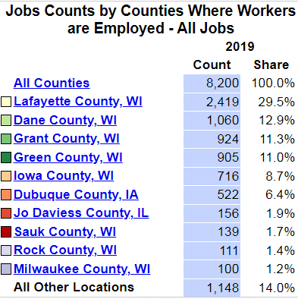
A large number of Lafayette county residents are working in different counties. Lafayette is a rural county with more metropolis areas and subsequently a greater variety of job opportunities found in surrounding counties. This results in the average Lafayette County residence traveling slightly longer distances to work. Mean travel time to work is 25.2 minutes for Lafayette County residents compared to Wisconsin’s mean travel time to work of 22 minutes, but less than the national mean travel time of 26.6 minutes.

Source: US Census Bureau OnTheMap Commuter Statistics 2019. https://onthemap.ces.census.gov/

Inadequate Social Support:
According to the County Health Rankings, social support networks are strong predictors of individuals’ health behaviors. Consequently people with poor family support, minimal interaction with others, or limited community involvement are at an increased risk of morbidity and mortality.
- Lafayette County had 9.6 membership associations per 10,000 population, compared to Wisconsin’s average of 11.4 according to 2019 data.
Source: 2022 County Health Rankings; 2015 County Health Rankings; 2014 County Health Rankings;

Physical Environment

Air Quality:
According to the County Health Rankings, elevated air pollution can have negative impacts on health by decreasing lung function, chronic bronchitis, asthma, and other adverse pulmonary effects. Fine particulate matter is emitted from forest fires, or formed from gases emitted from power plants, industries, and automobiles.
- The average daily density of fine particulate matter in micrograms per cubic meter was 8.8 in Lafayette County according to 2018 data. This is an improvement from the level of 11.9 reported in the 2015 County Health Rankings.
- The state average was 7.5 according to 2018 data.
Source: 2022 County Health Rankings

Drinking water violations:
Over the years the County Health Rankings has used various measures to assess water quality. In the 2022 rankings, using 2020 data, whether or not health related drinking water violations were present was used.
- According to the EPA, 322 people were served by a Community Water System with a health related drinking water violation since 2015.
- 31 of the 72 counties in Wisconsin had a drinking water violation in 2020.
Source: 2022 County Health Rankings

Child lead poisoning:
According to the Wisconsin Department of Health Services, lead poisoning can lower IQ and attention span, cause learning disabilities and developmental delays, as well as have various other health and behavioral effects in young children. Most exposure to lead occurs in buildings built before 1978 with lead-based paints or lead-tainted dust in the environment. In 2012, the CDC lowered the intervention blood lead level from 10 micrograms per deciliter (mcg/dL) to 5mcg/dL.

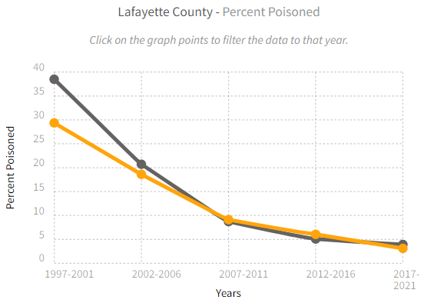
- Based on 2017-2021 data, 3.11% of tested children under age 6 in Lafayette County had blood lead levels higher than 5mcg/dL.
- Wisconsin had an average of 3.93% of children with blood lead levels higher than 5mcg/dL.
- The left chart shows the average rate of children who tested positive for lead poisoning from every 5 years 1997-2021.

Blood Lead Testing Data for Children Less than 6 Years of Age
Years | Number of Children Tested in Lafayette | Number Tested 5mcg/dL or above in Lafayette | Rate of 5mcg/dL or above in Lafayette | Rate of 5mcg/dL or above in Wisconsin
1997-2001 | 1001 | 294 | 29.37% | 38.5%
2002-2006 | 968 | 180 | 18.6% | 20.72%
2007-2011 | 876 | 80 | 9.13% | 8.72%
2012-2016 | 810 | 49 | 6.05% | 5.08%
2017-2021 | 611 | 19 | 3.11% | 3.93%
*Rate is number of children with an elevated blood lead level divided by the number of children tested in the county.
Sources: Wisconsin Department of Health Services, Environmental Public Health Data Tracker, Childhood Lead Poisoning https://dhsgis.wi.gov/DHS/EPHTracker/#/map

Primary Data
Stakeholder and Community Survey

We began our primary data collection with surveys provided to community stakeholders in

2021. Due to COVID, we were not able to begin our community survey until July of 2022. An
online community health needs assessment and survey was available in English and Spanish was available for community members to complete July-November of 2022. Paper copies were also made available to community members in both English and Spanish. The survey asked about people’s thoughts on the county’s current state of health, their personal health and what could improve our county’s health. The survey was mainly multiple choice with comment boxes available. Residents were also able to leave a general comment suggestions at the end of the survey. The survey took around 8 minutes to complete and we had XX amount of surveys completed. As an incentive to complete the survey, persons who filled out the survey could include their name and contact information for a chance to win a $25.00 gift card to a local business.

Youth Risk Behavior Survey

The Youth Risk Behavior Survey (YRBS) is a comprehensive health and wellness surveillance tool developed by the Centers for Disease Control and Prevention (CDC) and administered by states and municipalities. Since 1993, Wisconsin’s Department of Public Instruction (DPI) has administered the YRBS to a representative sample of Wisconsin high school students every two years. The results of that survey administration form the basis for Wisconsin’s official, state-level YRBS statistics. Those state-level statistics only represent the state as a whole and cannot be broken down to other geographic levels, such as county, municipality, or school district.

In the 2020-21 school year, there were public schools in Lafayette County that served high school students, including public charter, virtual, or other types of schools. 5 of these schools (71%) participated in the survey.

Participating schools included:
Shullsburg High School, Benton High School, Darlington High School, Pecatonica High School, Argyle High School.

Some key findings are below. The slides below were used in a presentation from our first Community Health Improvement Planning Meeting to highlight findings from the YRBS.

Reported Mental Health of Students:

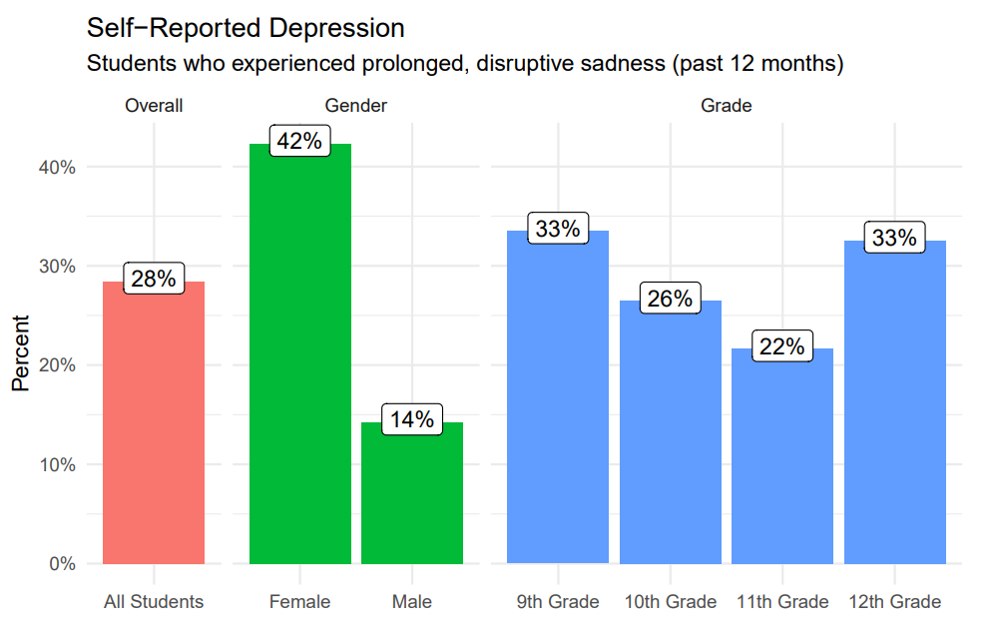

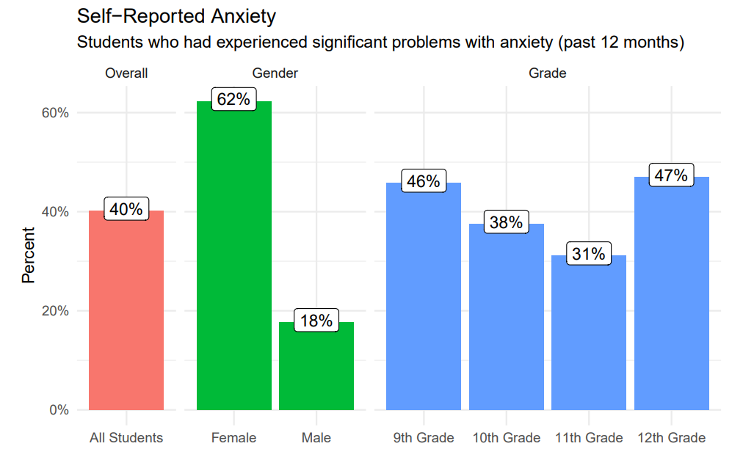

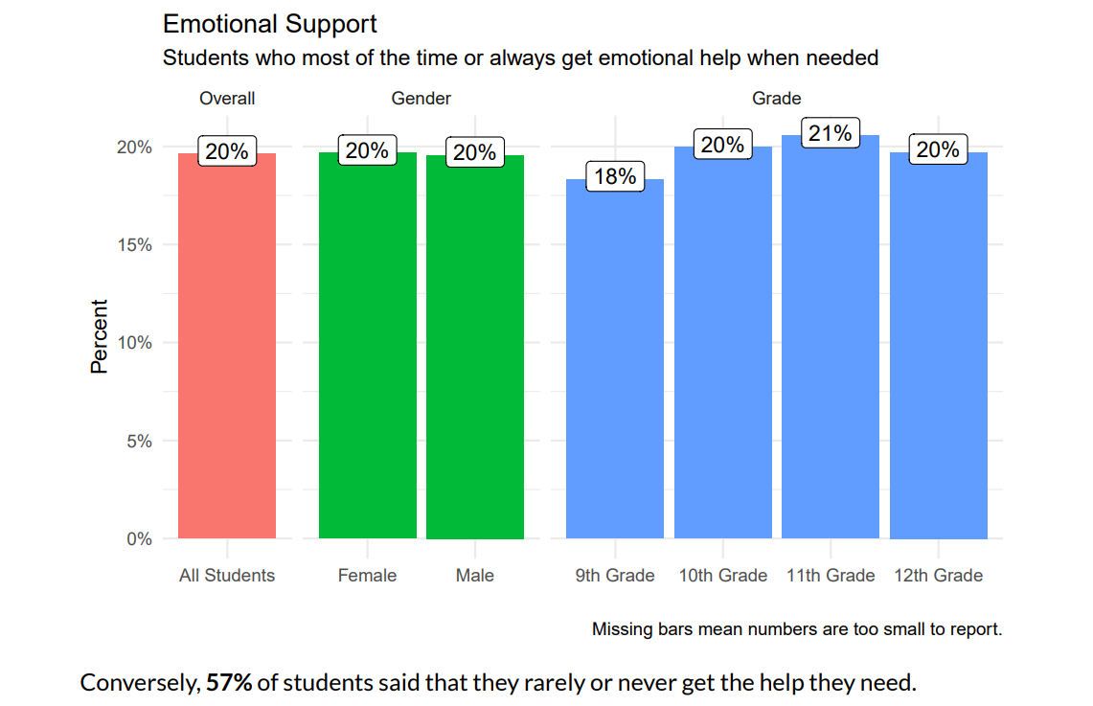

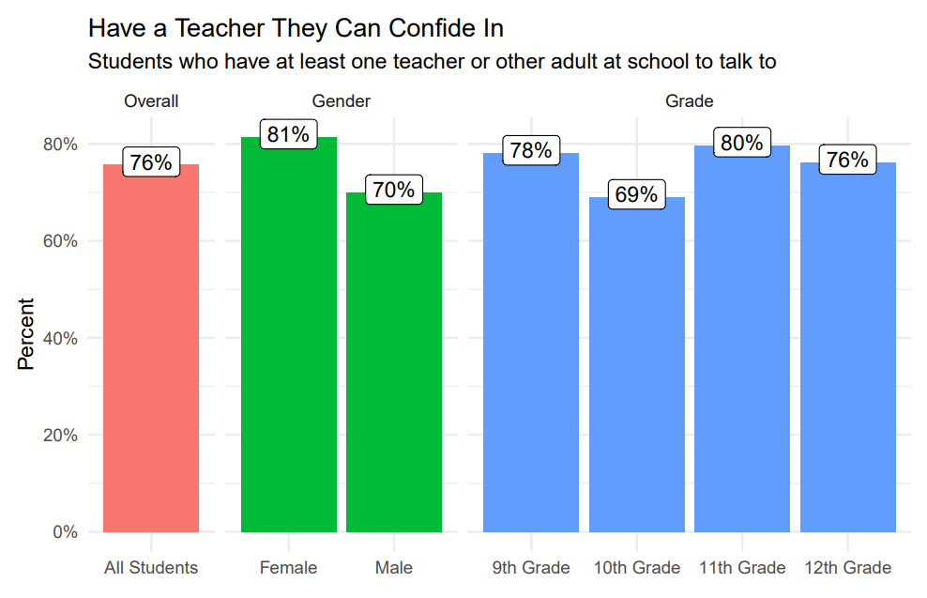

Source: Centers for Disease Control and Prevention. 2021 Youth Risk Behavior Survey Data. Available at: www.cdc.gov/yrbs.

Part 1 – Stakeholder Interviews/ Survey

Key stakeholder interviews and surveys were used to gather thoughts and opinions from a broad range of individuals identified as influential in the community. Questions were asked concerning the perceived scope of health and healthcare, factors of good and poor health, availability of resources, and specific roles each interviewee would take to support public health efforts in Lafayette County. The core questions were designed to gather information about key stakeholders’ general understanding and expectation of health, public health, and the healthcare system.
The overall purpose for the stakeholder interview and survey was to:
- Obtain a better understanding of key stakeholder’s understanding and expectations of healthcare and public health in Lafayette County.
- Identify the stakeholder’s greatest health concerns in the county.
- Learn what motivates stakeholders to commit to help achieve and support a healthy community.
- Gain qualitative data to complement the secondary quantitative data.

Stakeholder Interview/Survey Methodology
Due to the COVID pandemic, stakeholders were given the option to take an online survey or participate in a traditional interview via phone. We had 26 stakeholders participate. All stakeholders chose the online version of the survey.

Stakeholders contacted included Lafayette county employees and elected officials, members of law enforcement, religious officials, school district employees, business owners, and private citizens, to name a few. Key stakeholders were invited to participate in the interview by an initial contact email sent by the Health Department Director. The survey link was provided in the email.

All responses were kept strictly confidential. Respondents were assured only comments relevant to overall themes of the interview would be in the final report and no identifying individual attributions would be made.

Key Stakeholder Summary of Results
A summary of the key answers based on general themes for each individually asked question is listed below.

Definition of Health
Question: What is your definition of health? Describe the role health plays in the community?

The majority of respondents identified health as matter of holistic well-being. The importance of physical, emotional, mental and spiritual health was a general theme. This is consistent with the World Health Organization’s (WHO) definition of health. The ability to fight illness, participate in desired activities, or manage a chronic illness were also commonly listed as factors.

Many respondents identified a healthy community as not just a community that is free from environmental hazards or illnesses. A health community is an important factor to a strong economy and is essential to promote productivity and wellness for residents. Responses also showed that not only do we need a healthy community for our members, we need healthy members to make our community strong.

Definition, Role, and Scope of Public Health
Question: How do you define public health? What do you see as its role in the community?

The common definition of public health from respondents involved the health of the community. Stakeholders were consistent in their view of public health being an essential component of the community.

The majority of respondents identified public health as governmental body that provides health information and education so that all community members can be healthy. Disease prevention and health promotion were commonly referred to as roles of public health. Disaster preparedness and human health hazard control were listed as some examples.

A common theme was that public health’s role was to provide education, health promotion and disease prevention. Some respondents identified public health’s role changes as the needs in the community change. Public Health should collect, evaluate and study these changes to provide services. Also, some answers pointed to the health department as a way to access to medical services for individuals and families who could not otherwise afford them. Reproductive health vaccinations and other screenings were given as examples.

A few respondents also stated that public health should work with area health care providers and community partners to ensure the health of community members.

Factors Contributing to Good Health
Question: What factors contribute to good health in Lafayette? With respect to health and healthcare, what are Lafayette County’s strengths? What is being done well?

A variety of responses were given to this question. The general theme focused on the physical, environmental, access to healthcare and treatment. Community factors were often identified as contributors to good health. These included the opportunities for physical activity, low unemployment rates, that we have good libraries, schools, law enforcement agencies, EMS and fire departments.

A couple of respondents noted the advantages of the rural environment. Examples listed included community members that help each other, low crime and clean air and water.

The general consensus was the accessible healthcare system in Lafayette County is a major strength. Comments included that we committed health care workers that include Memorial hospital, clinics, pharmacy, chiropractic care and mental health providers. The communication and collaboration between the health department, hospital, clinics, nursing home, human services and other partners was frequently mentioned. Additionally, a number of respondents acknowledged the importance of the Lafayette County Health Department providing relevant health information, participating in local coalitions and providing preventative health care such as vaccinations.

Factors Contributing to Poor Health
Question: What factors contribute to poor health in Lafayette? Describe ways to address these factors contributing to poor health? What barriers do you see in addressing these factors?

An individual’s lifestyle behavior and choices was a common theme. The easy access and overuse of alcohol, tobacco, illegal drugs, in addition to unhealthy eating, lack of options for healthy foods and lack of exercise activities were frequently listed.

While access to health care was seen as a strength, multiple stakeholders mentioned that some groups may not have access to health care or resources to maintain or improve their health.
Likewise as good water quality was seen as a strength several stakeholders listed threats to water quality/maintaining our water quality as a factor as contributing to poor health.

On the other end of the spectrum, the majority of respondents also recognized the impact of poverty and a person’s social economic status on poor health outcomes. Stakeholders noted unemployment and poverty make it difficult for individuals to practice a healthy lifestyle or access care. This aligns with the socio-ecological model. This is the idea that a person’s health is not solely dependent on the individual but rather multiple layers including the social environment.

A few stakeholders also noted challenges in reaching the Hispanic or underserved populations. Others noted was that funding for programs to assist our communities is not sufficient.

Education was the most frequently listed recommendation to address the factors contributing to poor health. Also, work around mental health was mentioned often. Suggestions included to increase services/access, reduce the.

Outreach to the community and to developing and strengthening partnerships between local stakeholders, was also suggested. This would include forming relationships with “minority leaders” to gain a better understanding of our cultural diversity.

The barrier listed most often was lack of funding or resources. Other barriers that were identified were how we educate our elected officials on our county’s needs, lack of people to do the work, limited buy in from residents, communication barriers such challenges to reach everyone in our community.

Health Issues Prioritization (highest to lowest)
Respondents were asked to list what they thought to be the top three health problems in Lafayette County. A list of example problems was provided. Stakeholders were encouraged to choose any three issues they thought needed the most attention and were not limited to the example list.

The following ordered list is a summary of the most-often through the least-often suggested health topics by stakeholders:

- Drug and Alcohol Issues
- Obesity and Overweight
- Mental Health and Emotional Well-being
- Healthy Lifestyle Behaviors
- General Health
- Farm/ Rural Safety
- Cancer
- Aging Problems
- Access to care
- Minority concerns (Hispanic, undocumented laborers, Amish)
- Housing
- Income/Poverty

Discussion around the topics occurred in the interviews and some respondents left comments in the survey. Some notes from the interviews and surveys include:
- Obesity and overweight issues and Mental Health and Emotional Well-being had the same amount of responses by stakeholders
- Some respondents felt they were not qualified to answer or were unsure of the what issues should be prioritized
- Healthy Lifestyle Behaviors and concerns about General health were mentioned the same amount by stakeholders
- General health includes the singular mention of diabetes, heart health, preventative health measures, and access to health care system

After listing their top health priorities, respondents were asked how they thought these specific issues could be addressed in the community. This was followed by a question on barriers that may arise in addressing these issues.

Local Solutions and Barriers to Support
Question: How should Lafayette County go about addressing these health needs, and what services or resources should be used?

Education and promotion of healthy behaviors were the most frequently mentioned solutions. Health fairs, farm safety education sessions, other classes related to health, or healthy food choice promotion in grocery stores were suggested.

Collaboration among stakeholders and public and private organizations to address issues was also frequently mentioned as how to address the needs and as resources. Other suggestions to address barriers include: More mental health services, targeting behaviors demographics, translation of educational materials into Spanish, gaining community support for funding and resources

One respondent wrote about the need to, “Define what the problem (is), identify key stake holders, identify the determinants, implement strategies, and evaluate. This needs to be a very strategic and thought out process in order for it to be successful and sustainable.”

In addition to the above, other resources include multi- media outreach campaign, public service announcements, using already formed coalitions, such as the Mental Health Matters Coalition. Increase staff retention at county agencies, look for grants for funding.

Question: What barriers exist in this county to creating programs/ solutions for our health problems, and how would you suggest addressing them?

The lack of financial and staffing resources were the most frequently mentioned barriers to creating solutions or programs. Several respondents cites lack of the community awareness and buy in as barriers. Other barriers included access to reliable. Internet, transportation issues. For persons to access care outside of our county.

Addressing barrier responses included seeking out funding sources, continue education, and continue to strengthen partnerships, working with other agencies to target outreach, work with elected officials for funding and programs.

Community Support
Question: What role could you play in addressing the health needs/ improving the health of Lafayette County? How might you involve others?

Almost all respondents expressed a willingness to engage with the community and/or partner with other agencies to make Lafayette County a healthier place to live. Many noted they could provide education, advocate for change, or work with their specific entities such as library, school, business, department, church, or town to assist with programs that promote health. There was interest in working in partnerships to achieve specific and common health goals. Several respondents noted they would be willing to involve others in their coalitions, recruit volunteers or collaborate with other community partners to provide programming in their agency.

Other comments included comments to commend the health department on their current work and the work during the pandemic and to include Family Advocates as a partner.

“I love living here!”

“We must work with the entire community including recent immigrants.”

“There is a need for grief counseling, as well as other support groups such as AA, Narcotics Anonymous.”

Part 2 - Community Survey
Community Survey Methodology
A community survey was developed and distributed to county residents through social media networks and made available online. Posters and newspaper supplements with QR codes were used as well. Some questions from the 2015 Lafayette County Needs Assessment survey were incorporated into the current survey. This type of sampling method is non-randomized, so it is more difficult to confidently generalize the results. This type of sampling method is non-randomized, so it is more difficult to confidently generalize the results. The Community Health Needs Assessment, being similar to a quality improvement project, does not require the strict scientific methodology of a research study. However, attempts were made to improve generalizability of the survey results, which are described below. A copy of the survey can be found in the Appendix.

To notify the county residents of the survey, a link with a brief description was posted on the health department website. The health department and staff also posted the link in their social media feeds periodically throughout the survey open period. A link was also posted on Memorial Hospital of Lafayette County’s website. Flyers were hung at different locations including banks, libraries, schools, grocery stores, and Community Connections clinic directing people to the Lafayette County Health Department website to complete the survey. In attempts to encourage complete responses participants were incentivized with a chance to enter a drawing for one of four gift cards to a local business. Upon finishing the survey, those interested in entering the drawing were able to leave their contact information if they chose to do so.

The Hispanic, Amish/ Mennonite, and older adult populations were three populations the health department was most concerned would not be captured in an online survey. To target older adults, the health department distributed paper copies of the survey at the Lafayette County Housing Authority Buildings, ran ads in the paper and offered to mail surveys with a self-addressed stamped envelope. Paper copies were offered by a local resident to the plain community. As no identify information was asked on the survey, it cannot be determined if a person of Amish or Mennonite background completed the survey. As a means to include the Hispanic population, the online survey was designed with the option to be taken in Spanish. In addition, flyers translated in Spanish were distributed to local Hispanic owned businesses in Darlington. Also, flyers and paper copies of the survey were available at the Community Connections Free Clinic in Dodgeville where around 25% of their clients are from Lafayette County. In the future, it may be more effective to time the survey around the time of the Cinco de Mayo celebration in Darlington with paper versions of the survey or a computer set up for people to complete the survey on the spot.

Community Survey Results

Demographics
A total of 249 survey responses were collected. Of those, 209 (83.94%) Lafayette County residents completed more than 80% of the survey. 13 completed surveys were discarded for lack of evidence indicating county residency, e.g., no zip code listed. There was respondents ranging from the ages of 20-96 with a median age of 61.5. The age group 20-29 had the fewest number of respondents, and the age group of 60-69 had the highest number of responses. Only four respondents indicated they were Hispanic or Latino. The top four zip codes represented were 53530 (Darlington), 53586 (Shullsburg), 53803 (Benton), and 53516 (Blanchardville), respectively. Darlington and Shullsburg are the most populous areas of the county followed by Belmont and Benton. Consequently, it is interesting to see the Blanchardville area more represented in the survey. Residents in these area may have been more susceptible to survey advertising. However, there is representation from every zip code in the county. The median age of respondents was 61.5 which is significantly higher than the 2021 estimate of 41.1 for Lafayette County. Unsurprisingly 41% of the respondents indicated that they are currently retired.

Respondents Age | Percent
75+ (≤1947) | 18.60%
65-74 (1957-1948) | 22.67%
50-64 (1972-1958) | 23.26%
40-49 (1982-1973) | 15.70%
30-39 (1992-1983) | 15.12%
20-29 (2002-1993) | 4.65%

Summary of Key Findings:

Next Steps

For the 2023 health needs assessment the Lafayette County Health Department will begin discussions with our Board of Health, stakeholders/community partners and community members to discuss which challenges become the priority to work.

The priority or priorities are chosen for the Community Health Improvement Plan (CHIP) will determine future steps. For example, would it make sense to work with an existing coalition, or does the priority require a new coalition/working group being established? Who is the experts on the priority chosen? Will the health department play a lead role or does it may make sense for another agency to lead the work and the health department be a supporting partner?

References

U.S. Census Bureau. (2020). Decennial Census.
Accessed: March 2023, from www.data.census.gov

U.S. Census Bureau. (2017-2021). American Community Survey (ACS) 5-year estimates.
Accessed: March 2023, from www.data.census.gov

University of Wisconsin, Population Health Institute. County Health Rankings & Roadmaps 2022.
Accessed: March 2023, from https://www.countyhealthrankings.org/explore-health-rankings/wisconsin/data-and-resources

Wisconsin Department of Health Services. (2022-2023) Badgercare Enrollment Plus Monthly Reports.
Accessed: March 2023, from https://dhs.wisconsin.gov/badgercareplus/enrolldata.htm

Wisconsin Department of Health Services, Environmental Public Health Data Tracker. (2023) Asthma
Accessed: March 2023, from https://dhsgis.wi.gov/DHS/EPHTracker/#/map

U.S. Centers for Disease Control and Prevention. (2023) US Diabetes Surveillance System application.
Accessed: March 2023, from https://gis.cdc.gov/grasp/diabetes/diabetesatlas-surveillance.html

Wisconsin Department of Health Services, Wisconsin Interactive Statistics on Health (WISH), Mortality Module
Accessed: March 2023, from https://dhs.wisconsin.gov/wish/mortality/broad-form.htm

Wisconsin Department of Health Services, Environmental Public Health Data Tracker. (2023) Heart Disease and
Stroke. Accessed: March 2023, from https://dhsgis.wi.gov/DHS/EPHTracker/#/map

Wisconsin Department of Health Services, (2017) Wisconsin Public Health Profiles: Lafayette County
Accessed: March 2023, from https://dhs.wisconsin.gov/publications/p4/p45358-2017-lafayette.pdf

Wisconsin Department of Health Services, Wisconsin Interactive Statistics on Health (WISH), Cancer Incidence
Accessed: March 2023, from https://wish.wisconsin.gov/cancer/incidence.htm

Wisconsin Department of Health Services, Wisconsin Interactive Statistics on Health (WISH), Cancer Mortality
Accessed: March 2023, from https://wish.wisconsin.gov/cancer/mortality.htm

U.S. Centers for Disease Control and Prevention. (2023) Adult Obesity Prevalence Maps.
Accessed: March 2023, from https://www.cdc.gov/obesity/data/prevalence-maps.html

U.S. Centers for Disease Control and Prevention. (2021) High School Youth Risk Behavior Survey
Accessed: September 2023, from https://nccd.cdc.gov/Youthonline/App/Default.aspx

Jama Network, (2019) Estimated Deaths Attributable to Excessive Alcohol Use Among US Adults Aged 20 to 64 Years,
2015 to 2019. Accessed: March 2023, from https://jamanetwork.com/journals/jamanetworkopen/fullarticle/2798004

U.S. Centers for Disease Control and Prevention. (2015-2019) Alcohol-Related Disease Impact Application (ARDI)
Accessed: March 2023, from https://nccd.cdc.gov/DPH_ARDI/default/default.aspx

U.S. Department of Labor, Bureau of Labor Statistics. (2010-2021) Local Area Unemployment Statistics
Accessed: March 2023, from https://www.bls.gov/lau/tables.htm

Wisconsin Department of Workforce Development (2020) Wisconomy Major employers by County.
Accessed: March 2023 from https://www.jobcenterofwisconsin.com/wisconomy/pub/employer.htm#Viz

U.S. Preventive Services Task Force (2023) Breast Cancer: Screening.
Accessed: May 15, 2023, from
https://www.uspreventiveservicestaskforce.org/uspstf/draft-update-summary/breast-cancer-screening-adults

U.S. Census Bureau. (2019) OnTheMap Commuter Statistics
Accessed: March 2023, from https://onthemap.ces.census.gov/

U.S. Environmental Protection Agency. (2023) Safe Drinking Water Information System.
Accessed: March 2023, from https://sdwis.epa.gov/ords/sfdw_pub/r/sfdw/sdwis_fed_reports_public/200

Wisconsin Department of Health Services, Environmental Public Health Data Tracker. (2023) Childhood Lead
Poisoning. Accessed: March 2023, from https://dhsgis.wi.gov/DHS/EPHTracker/#/map

Appendix A Stakeholder Survey Questions:

Name/job title

1. What is your definition of health? Describe the role health plays in the community?

- How do you define public health? What do you see as its role in the community?
- What factors contribute to good health in Lafayette County? With respect to health and health care, what are Lafayette County’s strengths? What is being done well?
- What factors contribute to poor health in Lafayette County? Describe ways to address these factors contributing to poor health? What barriers do you see in addressing these factors?
- In your opinion, what are the top three health problems in Lafayette County and why?
- How should Lafayette County address these health needs? What services or resources should be used?
- What barriers exist in Lafayette County to create programs/solutions for our health problems? How would you suggest addressing these barriers?
- What role could you or your agency play in addressing the health needs/improving the health of Lafayette County residents? How might you involve others?
- Any other comments regarding improving the health of Lafayette County.

Your thoughtful responses to the following questions are greatly appreciated and will help direct programs at the Lafayette County Health Department.

Community Survey Questions and Responses

Appendix A

Community Survey Results:

What are the top five strengths of Lafayette County?

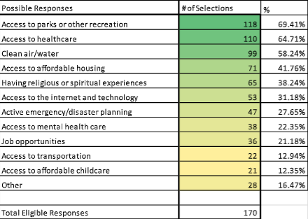

Respondents were able to contribute other responses. The majority of these responses included: a good quality of life, quiet, good schools, low crime, and little traffic.

What are five things Lafayette County can improve on?

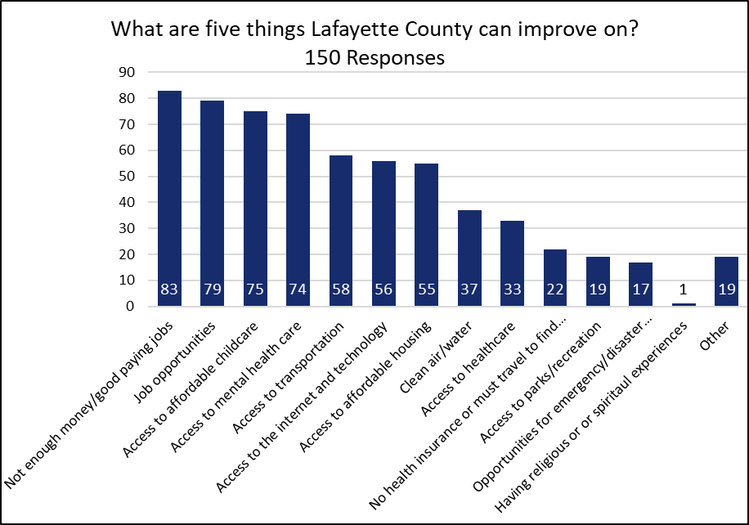

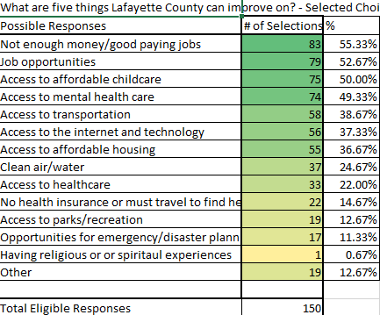

Top other responses included access to senior, handicapped housing, environmental issues (quality of water air soil, climate), increasing diversity or representation of diversity on the County Board

3. How do you feel about the following statement: Lafayette County is a safe place to live?
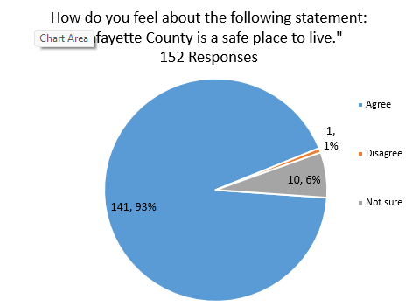

4. I have experience the below challenges with raising my family

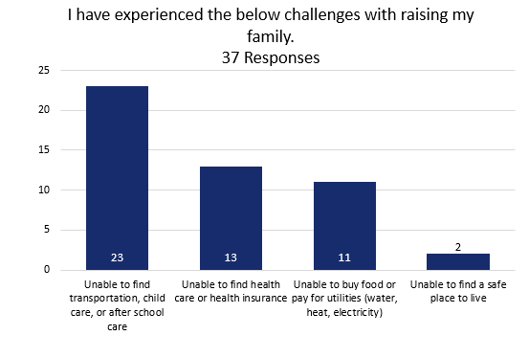
5. This question asked about internet access:

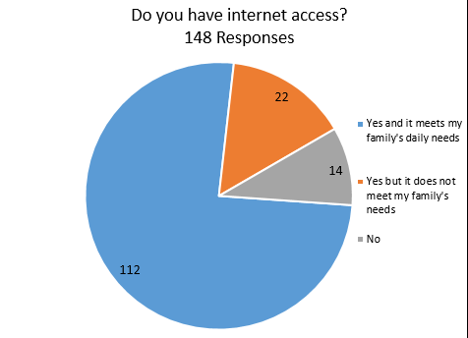

6.
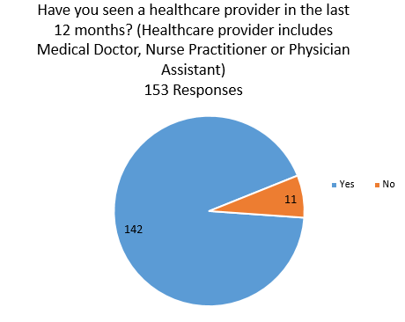

7.
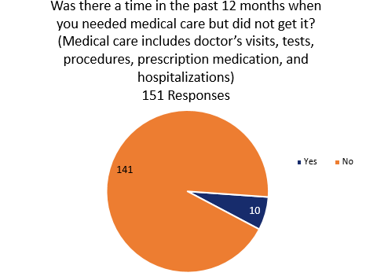

As a follow up to the above
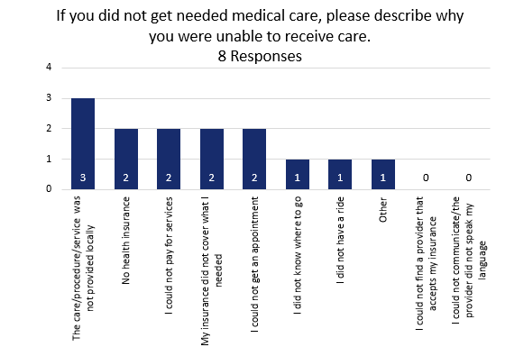
9. Are there other medical service
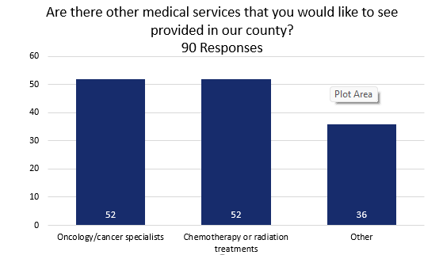

There were t26 other responses:
Top responses included
OB/Gym
Mental health providers- adult and pediatric
Dialysis
More specialty services
Allergy
Dental services

10. Question was asking if respondents felt we needed more of the specific services:

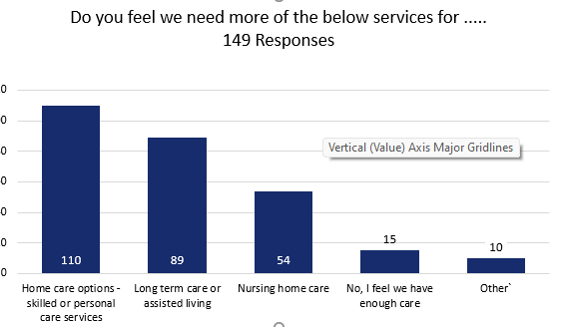

Services for the elderly including nursing home, retirement community, nursing home and assisted living, low maintenance living
Mental health
Rehab services
List all or top?????? Such mentioned once, etc.

11.
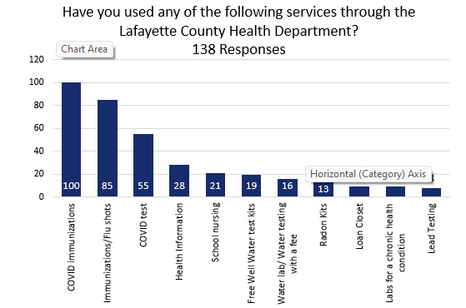

12. What kind of Health insurance
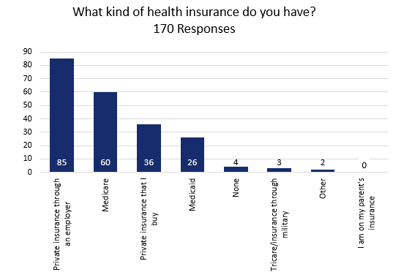
13.

Other answers included that it is too expensive, being self-employed
14.
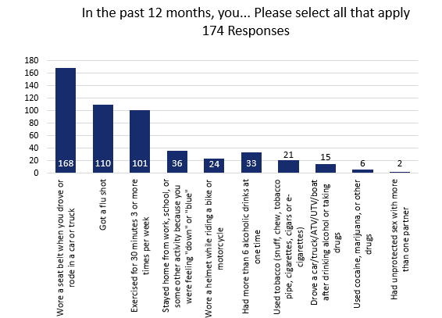

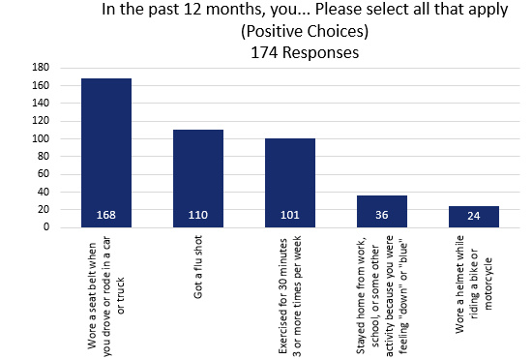

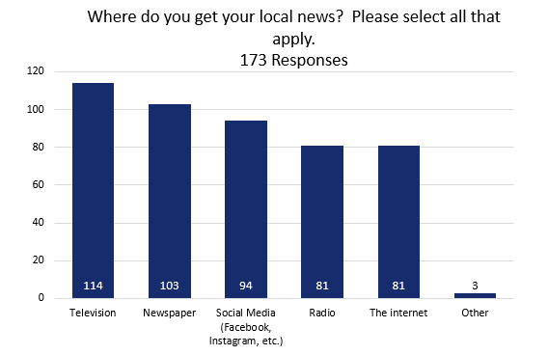
Other responses included: Village, YouTube, CNN, MSNBC, and CBS
Limited due to internet service

16.
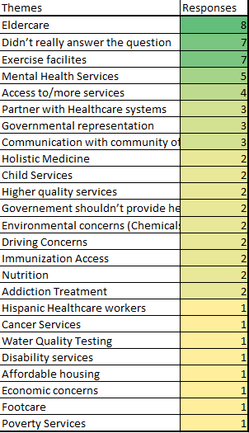

More holistic health opportunities
More physical fitness opportunities

17.
Age distribution
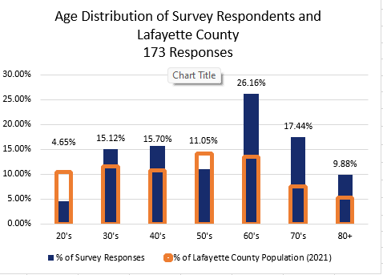

Zip code
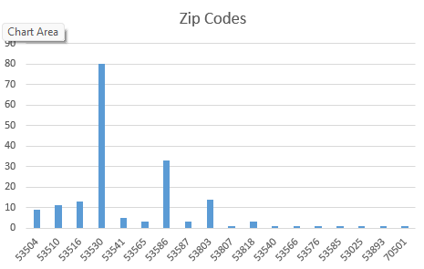

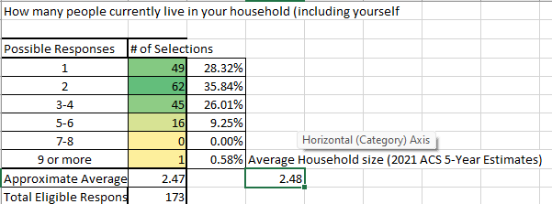

20.

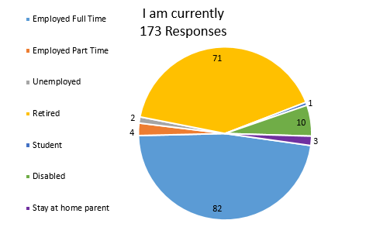

21. and 22. Survey Responses

