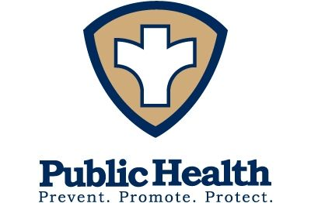

Lafayette County Health Department
2021 Annual Report

Lafayette County Health Department
729 Clay Street
Darlington WI 53530
608-776-4895
www.lafayettecountywi.org/healthdepartment

To the Lafayette County Board of Supervisors, Board of Health Committee, Colleagues, Partners and Lafayette County Residents:

I am pleased to share with you the annual report for the Lafayette County Health Department.

January 2021 saw us move into the second year of the COVID-19 pandemic. In January we began to administer COVID-19 vaccinations following guidelines set by the Wisconsin Department of Health Services. We started with small drive through clinics at our office, held clinics at the Ames Multipurpose Building and then, when demand for vaccines lessened, returned to our office for clinics. Thank you to our staff, our limited term employees’ (LTE), the many volunteers and MHLC staff who assisted us at our clinics. Thank you to the Highway Department for their assistance when we used the Ames Multipurpose Building.

As we learned in 2020, flexibility and resilience were key to continue to respond to the pandemic. Again, I would like to thank our dedicated staff, LTE’s and volunteers for their hard work in our continued response to the pandemic.

Thank you also to the Board of Health Committee, the Lafayette Board of Supervisors, Lafayette County Departments who assisted us these past two years. Thank you to our community partners, schools, MHLC, long term care care facilities, public safety and law enforcement partners, pharmacies, Lafayette County Schools and our community organizations for the partnerships and assistance we have received. Thank you to our community members for your support throughout the pandemic.

Thank you for taking the time to read our report. Please contact us at the Health Department if you have questions or concerns at 608-776-4985 or publichealth@lafayettecountywi.org

Working together for a healthier community,
Julie Leibfried, RN, BSN
Health Officer/Director
Lafayette County Health Department

Health Committee

Bob Boyle (Chairman)- County Board Supervisor
Carol Korn- County Board Supervisor
Kriss Marion- County Board Supervisor
Donna Flannery- County Board Supervisor
Lois Finnegan- Lay Member
Chris Fortin- Lay Member
Kristie Lueck-Lay Member

Volunteer Medical Director

Dr. Lori Neumann, MD

Staff

Julie Leibfried, RN, BSN Health Director
Danielle Steger, RN, BSN Public Health Nurse
Leah Walrack, RN, BSN Public Health Nurse
Molly Blackbourn, RN, BSN Public Health Nurse
Erin Hastert, Public Health Technician
Bree Harker, Administrative Deputy (October-December 2021)
Jackie Scott, Administrative Deputy (January- August 2021)
Troy Moris, RS Environmental Health Coordinator

COVI-19 Response Team
Kim Sniff
Karla Blackbourn
Marian Olson
Luanne Donahue
Alex Wright- UWP Intern

Mission Statement

“Promoting, Protecting and Preserving Health while Providing Care with Partnerships throughout our Communities”

Our Vision

“Live Well Lafayette” Active, healthy families and people of all ages, abilities and cultures living, playing and working in thriving communities.

The Lafayette County Health Department uses the Ten Essential Public Health Services as a framework to provide services to our residents every day.

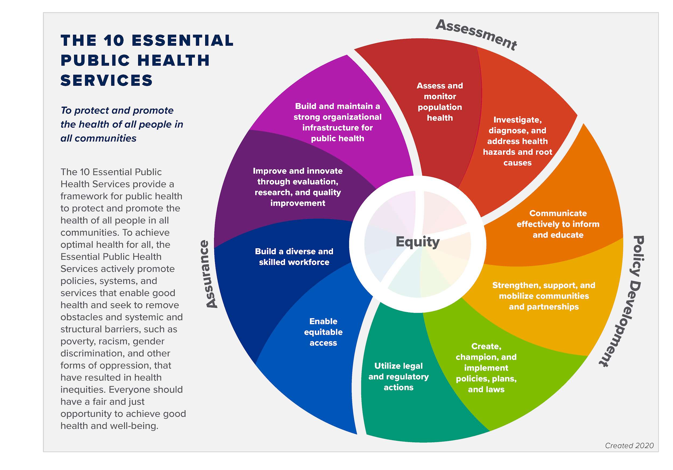

Public Health Services

Keeping you informed
To keep residents informed about COVID and other public health information, we have a Facebook and webpage that have current and relative information. Stay up to date by visiting https://www.facebook.com/lafayettecountyhealthdepartment

and/or https://www.lafayettecountywi.org/healthdepartment

Health Equity
The Lafayette County Health Department values all individuals and populations equally. We focus efforts to address inequalities and promote optimal health for all.

Communicable Disease Reporting and Investigation:
According to Wisconsin State Statute Chapter 252, local health departments are responsible for investigating certain communicable diseases. The Lafayette County Health Department investigates communicable diseases reported to us by area hospitals, clinics, schools, long term care facilities, and other reporting sources. We offer education and materials regarding communicable disease and prevention. We also offer tuberculosis screening, treatment and follow up care as needed. The number of reported illnesses increased significantly in 2020 due to the COVID-19 pandemic. Below are the number of reports we have received on certain reportable diseases/infections.

Blastomycosis | 1
Campylobacteriosis | 10
Carbon Monoxide Poisoning | 5
Chlamydia Trachomatis Infection | 33
Coronavirus, Novel 2019 (Negative and Results) 2021 | 5,219
Coronavirus, Novel 2019 Probable cases 2021 | 105
Coronavirus, Novel 2019 Confirmed cases 2021 | 1271
Coronavirus, Novel 2019, Reinfection | 5
Cryptosporidiosis | 6
E- Coli, Enteroinvasive (EIEC)/Shigella | 1
E-Coli, Enteropathogenic (EPEC) | 9
E-Coli, Shiga Toxin Producing (STEC) | 2
Gonorrhea | 4
Hepatitis B, Chronic | 4
Hepatitis C, Acute | 1
Hepatitis C, Chronic | 24
Influenza | 252
Influenza Associated Hospitalization | 6
Lyme Laboratory Report | 10
Malaria | 1
Non Reportable | 1
Pertussis (Whooping Cough)- Suspect | 6
Q Fever, Acute | 1
Polio (suspect) | 1
Streptococcal Disease, Invasive, Group B | 3
Streptococcus Pneumoniae | 1
Syphilis Reactor | 2
Toxoplasmosis | 1
Tuberculosis (latent TB infection) | 1
Varicella (Chickenpox) | 4
Total | 6,995

Environmental Health

Our Environmental Health programs provide community outreach and education on environmental health issues. The following areas are handled within our Department:

- Air & Water Quality- Water & Radon Test Kits are available at our office. There is a charge for water kits. Some free water testing may be available for pregnant women or households with a child under one year of age. Radon test kits are free and provided to Lafayette County Residents.
- Human Health Hazards- Investigations may take place to make sure that our residents are living in safe conditions.
- Mosquito & Arboviral Control- Education on prevention and treatment are available.
- Asbestos & Mold- Educational materials are available.
- Any type of inspection is based on the environmentalists' expertise.
- Lead Hazards- Educational materials are available. Inspections are done when warranted.
- Public Health Nuisance- Investigates and addresses public health nuisances, and enforces the public health nuisance ordinance.
- Flood Safety- Educational materials and clean up kits available.

Environmental health contacts and visits made by our Environmental Health Consultant, Troy Moris.

Environmental Concern | Number of Contacts | Number of Home/Site Visits
Lead | 20
Radon | 29
Water | 18
Asbestos | 21
Solid waste | 36 | 12
Air Quality | 42 | 1
Sewer | 19
Animal | 21
Housing | 51 | 12
Food |  | 1
Fit Testing
Total | 257 | 26

Childhood Lead Testing

Our Public Health Nurses conduct lead testing and follow-up including phone calls, home visits, education, consultation with the child’s health provider. A home risk assessment is conducted if levels are 5 or greater as this level is considered “lead poisoning” and can impact a child’s health. A home visit is performed by our environmental health care consultant and a nurse for lead levels 10 and over.

Number of lead tests below 5 mcg/dl | 80
Lead tests over 5 mcg/dl | 1
Total Lead tests: | 81
Home Investigations | 0

Rabies Prevention

The Lafayette County Health Department receives reports of animal bite orders primarily through the Lafayette County Sheriff's Department. According to the Wisconsin State Statute 95.21 local health departments are required to investigate reported bites.

Dog Cases | Quarantine- home | Quarantine- Vet Clinic | Specimens to state lab
38 | 38 | 0 | 0

Cat Cases | Quarantine- home | Quarantine- Vet Clinic | Specimens to state lab
15 | 12 | 0 | 3

Other Species:

Bat Exposures | 2
Bat sent to state Lab | 2
Other wild animal exposures | 0

Immunization for Children and Adults

Our Department offers vaccines for adults and children through the federal VFC and VFA programs. In 2021, LCHD gave 10,767 shots to 5,585 people including 8,612 Covid vaccinations and 830 flu vaccinations.

Immunization Program Highlights:

- Our office began providing COVI-19 immunization in January of 2021
- Had numerous drive through clinics and indoor mass vaccination clinics
- Provided clinics with extended hours for COVID, flu and childhood immunizations
- Provided Flu and COVID-19 vaccination clinics at schools
- Provided COVID-19 vaccines at the Lafayette County Jail and several area long term health facilities
- Worked with Memorial Hospital of Lafayette County and Clinics to coordinate COVID-19 booster vaccinations and clinics

Our 2021 Benchmark Goal:

By December 31, 2021 56% of the children residing in the Lafayette County Health Department jurisdiction who turn 24 months of age during the contract year will have received 4 DTaP, 3 Polio, 1 MMR, 3 Hib, 3 Hepatitis B, 1 Varicella, and 4 Pneumococcal Conjugate (PCR) (4313314 series) vaccinations by their second birthday.

Our immunization benchmark percentages increased from 2020.

- 2021 Benchmark Report for Children 24 months & under: Total Clients:231
- Clients that met all benchmark criteria: 111 (48%)
- Late up-to-date clients: 128 (55%)
- Amish Clients: 69 (30%)

In comparison to 2020

- 2020 Benchmark Report for Children 24 months & under: Total Clients:245
- Clients that met all benchmark criteria: 108 (44%)
- Late up-to-date clients: 124 (51%)
- Amish Clients: 41 (17%)

Women, Infants and Children Program (WIC)

The WIC program is a nutrition program for women who are pregnant, breastfeeding or postpartum: infants and children younger than 5. WIC provides nutrition education, breastfeeding education and support, supplemental nutritious foods, and connections to other community services.

The Lafayette County Health Department does not provide the WIC program, but refers clients to the program. Prior to COVID-19, SWCAP was coming to our building to provide this service. For the WIC program, Lafayette County had an unduplicated count of 278 women, infants, and children in 2021.

Wisconsin Well Woman Program (WWWP)

The WWWP provides preventive health screenings such as mammograms and cervical screening tests to women with little or no health insurance coverage. The program is administered through Juneau County. Additionally, women who are enrolled in the WWWP program and are found to have breast or cervical cancer are eligible to be enrolled in WWWP Medical Assistance so that their treatment is covered.

WWWP Screening numbers for Lafayette County
Lafayette County Residents enrolled: 55
New Enrollments 2021- 13
Lafayette County residents screened: 21
Lafayette County residents enrolled in WWWP Medical Assistance- 2

Covid Testing

The Lafayette County Health Department offered free COVID-19 community testing. The health department administered 430 tests. Participants were asked to register online using COVID Connect, a registration program through the State Department of Health Services . LCHD staff provided assistance for participants who could not or had difficulty registering.

School Nursing Services

The Lafayette County Health Department provides school nursing services to six schools in the County. This service is contracted individually with each school. Our Public health Nurses (PHN) play a crucial role in student’s health care needs at school, home and in the community. School nurses promote student’s health and safety, intervene with actual and potential health problems, provide case management services and provide training as needed to school staff. School nurses actively collaborate with other partners to build a student’s and their family’s capacity for self-management, self-advocacy and learning.

School nursing services provided include:

- Immunizations
- Vision and Hearing Screening
- Vision, health and dental referrals
- Assistance obtaining care for families without insurance
- Education and planning around student health needs
- Employee health
- Lice screening and follow-up
- Communicable Disease follow-up
- Emergency Nursing Services
- Human Growth & Development education
- Blood Borne pathogen education and training

Lafayette County Human Services Nursing

Lafayette County Health Department (LCHD) nursing staff provide medication and disease management services for residents of Lafayette County who suffer from chronic mental illness. Public Health Nurses (PHN) provide medication management and skilled nursing services through Lafayette County Human Services Department programming in an ongoing collaboration to serve the needs of mentally ill residents within Lafayette County.

During 2021, PHNs assisted 37 county residents in the Community Support Program (CSP) and Comprehensive Community Service (CCS) Program. These services entailed medication and health management, which enabled these individuals to live more full and independent lives. Throughout 2021, there were a total of 745 client contacts made among the 37 clients involved in CCS and CSP. Due to the continued COVID-19 pandemic, PHNs traveled to residents’ homes in addition to seeing client’s in the office in an effort to minimize patient’s exposure to COVID-19. To ensure collaborative wrap- around care, PHNs meet with CCS and CSP case managers and psychiatric providers weekly in addition to completing one-on-one patient education and skilled nursing assessments in the mental health clinic. PHNs play an integral role in patient care by acting as a clinical liaison between the patient and their mental and/or medical health care providers.

In addition to the services provided in the community based programs at Human Services, PHNs also assist with case management of patients who participate in Outpatient Mental Health Services, Alcohol and Other Drug Abuse Services, and Emergency Mental Health Services. PHNs assist with drug test sampling for Family Services Unit cases, as well.

Loan Closet

Our Department offers a loan program for gently used walkers, wheelchairs and other small durable medical equipment. This program is funded through donations from residents and healthcare agencies in the County. We ask for a small donation for any equipment that is borrowed and we accept gently used walkers and wheelchairs for this program.

Sharps Program

Lafayette County Health Department offers a free sharps container and disposal program. This program offers a safe way to dispose of sharps containers. Residents can also pick up empty sharps containers to properly dispose of their sharps at home.
TNC (Transient Non-Community) Water Systems

Our Health Department ensures safe drinking water at all establishments in the County who provide their own private well water to the public. This is done through a process of regular testing, education and guidance for these establishments. The Health Department does testing on establishments that serve a minimum of 25 people for at least 60 days/year, but not the same 25 people over 6 months. The most common establishments that we serve through this program are campgrounds, restaurants, taverns, churches, parks and golf courses. The Health Department works closely with the Wisconsin Department of Natural Resources for this program.

Inventoried Transient Non-Community Water Systems | 27
Annual Site Visits | 19
Additional Nitrates | 5
Additional Bacterial | 16
Seasonal Sites | 5
Follow Ups | 4
Level 2 Visits | 2
Sanitary Site Surveys | 8

Water Quality Program and Bacteria Lab

Lafayette County Health Department recommends that all wells used for drinking water be tested annually for safety. In 2019, the Department became DATCP Certified Water Testing Laboratory for Bacteria (total coliform). In addition to the lab, our Department offers private well water testing kits along with educational materials and techniques that allows residents of the County to properly test and monitor their own well water.

The number of tests performed are below.

Sample Type | Number of Samples
Bacteria- Absent | 144
Bacteria- Present | 37
Bacteria testing total | 181
E. Coli Absent | 181
E. Coli Present | 0
Nitrate | 31
Lead  Arsenic | 2  3
Total Tests | 311

Public Health Preparedness and Response

Our Department’s Emergency Preparedness Program is funded through grant dollars from Federal pass through funding and the Wisconsin Department of Public Health. This allows our Department to train and prepare for public health emergencies. Training includes topics such Incident Command, Epidemiology/disease follow-up, mass vaccination and treatment clinics and many other skills that pertain to a public health emergency.

These past funds have helped us prepare and respond to the current COVID-19 pandemic. Our past training has made us able to plan and implement drive through testing and immunization clinics as well as walk-through immunization clinics. Relationships with other counties during past preparedness exercises have also ensured successful relationships during the current pandemic.

Regional and Local Participation and Collaboration

- Southwest Alliance for Tobacco Prevention
- Mental Health Matters Lafayette County
- Community Connections Free Clinic
- Highway Safety Committee
- Lafayette County Emergency Preparedness Task Force
- Maternal Child Health
- Live Well Lafayette
- Lafayette County Rural Safety Coalition
- Neighbors and Amigos Council
- Wisconsin Association of Local Health Departments and Boards
- National Association of School Nurses
- Wisconsin Public Health Association
- South Central Wisconsin Healthcare Emergency Readiness Coalition
- Southwest Wisconsin Immunization Coalition
- Wisconsin Department of Natural Resources
- Wisconsin State Lab of Hygiene
- Environmental Research and Innovation Center- UW-Oshkosh
- Iowa County Health Department

