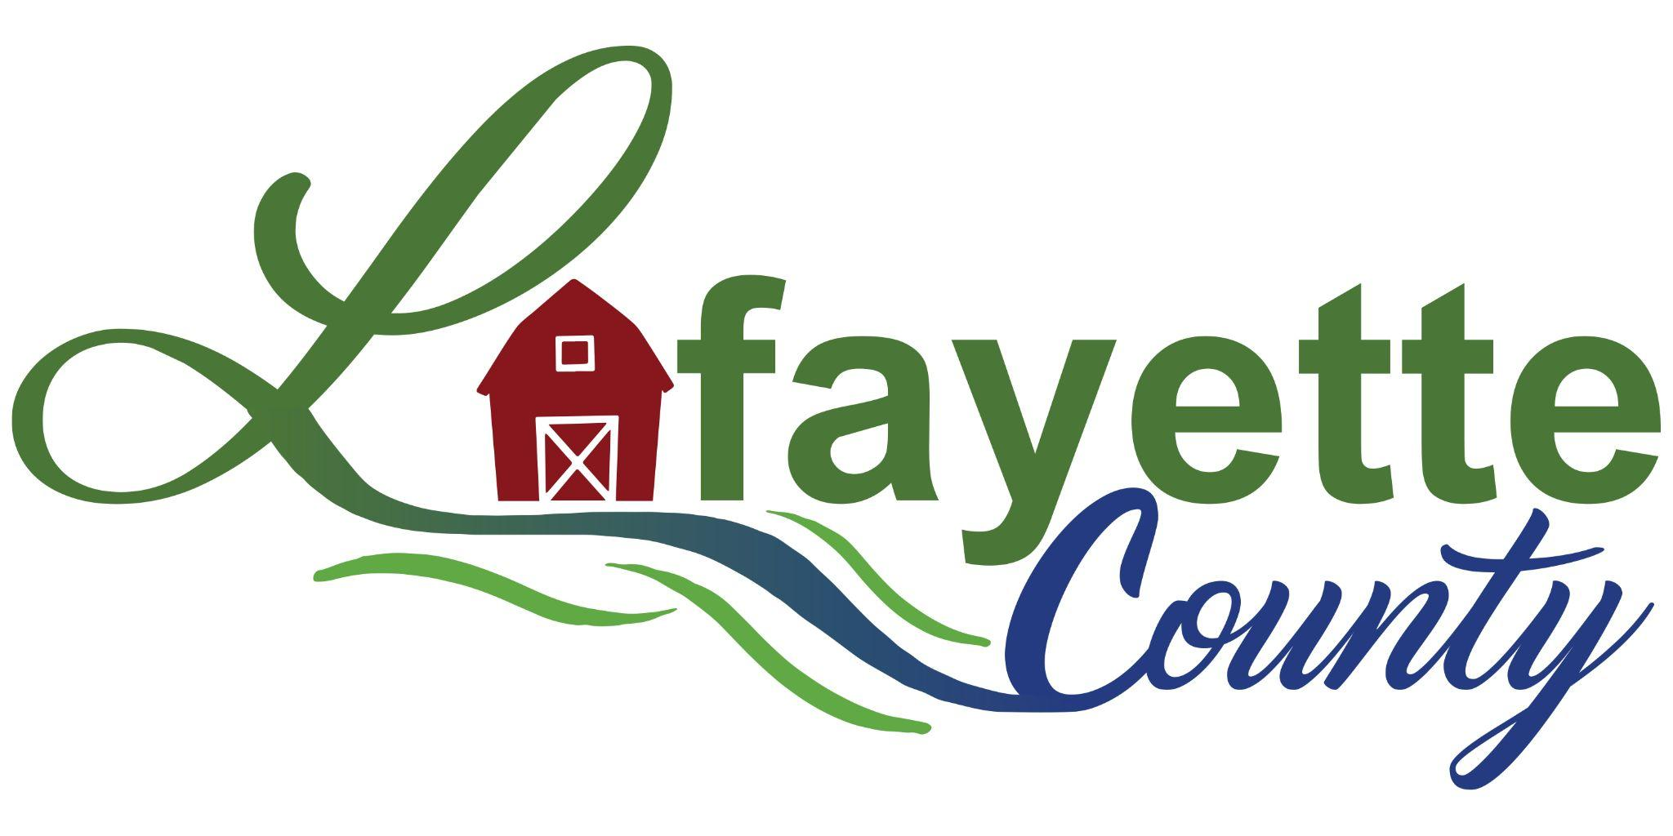

Lafayette County Health Department
2022 Annual Report

Lafayette County Health Department
729 Clay Street
Darlington WI 53530
608-776-4895
www.lafayettecountywi.org/healthdepartment

To the Lafayette County Board of Supervisors, Board of Health Committee, Colleagues, Partners and Lafayette County Residents:

I am pleased to share with you the annual report for the Lafayette County Health Department.

January 2023 saw us move into the third year of the COVID-19 pandemic. We continued with COVID vaccinations, testing, disease investigation and prevention efforts. Thank you to our staff, our limited term employees’ (LTE), the many volunteers and MHLC staff who assisted us at our clinics. Thank you to the Highway Department for their assistance when we used the Ames Multipurpose Building.

Resilience and resourcefulness remained key attributes of our staff as they continued to respond to COVID-19 and resumed programs and services that had been put on hold during the pandemic. Again, I would like to thank our dedicated staff, LTE’s and volunteers for their hard work during this time.

Thank you also to the Board of Health Committee, the Lafayette Board of Supervisors, and other Lafayette County Departments who assisted us these past two years. Thank you to our community partners, schools, , long term care care facilities, public safety and law enforcement partners, pharmacies, Memorial Hospital of Lafayette County, Lafayette County Schools and our community organizations for the partnerships and assistance we have received. Thank you to our community members for your continued support.

Thank you also for taking the time to read our report. Please contact us at the Health Department if you have questions or concerns at 608-776-4985 or publichealth@lafayettecountywi.org

Working together for a healthier community,
Julie Leibfried, RN, BSN
Health Officer/Director
Lafayette County Health Department

Health Committee

Bob Boyle (Chairman)- County Board Supervisor
Rita Buchholtz- County Board Supervisor
Kriss Marion- County Board Supervisor
Tim Olmstead- County Board Supervisor
Lois Finnegan- Lay Member
Chris Fortin- Lay Member
Kristie Lueck-Lay Member

Volunteer Medical Director

Dr. Lori Neumann, MD

Staff

Julie Leibfried, RN, BSN Health Director
Danielle Steger, RN, BSN Public Health Nurse
Molly Lee, RN, BSN Public Health Nurse
Leah Walrack, RN, BSN Public Health Nurse through September 2022
Erin Hastert, Public Health Technician
Bree Harker-Hastert, Administrative Deputy
Troy Moris, RS Environmental Health Coordinator

Limited Term Employees

Kim Sniff
Karla Blackbourn
Marian Olson
Luanne Donahue

Mission Statement

“Promoting, Protecting and Preserving Health while Providing Care with Partnerships throughout our Communities”

Our Vision

“Live Well Lafayette” Active, healthy families and people of all ages, abilities and cultures living, playing, and working in thriving communities.

The Lafayette County Health Department uses the Ten Essential Public Health Services as a framework to provide services to our residents every day. CHECK for updates

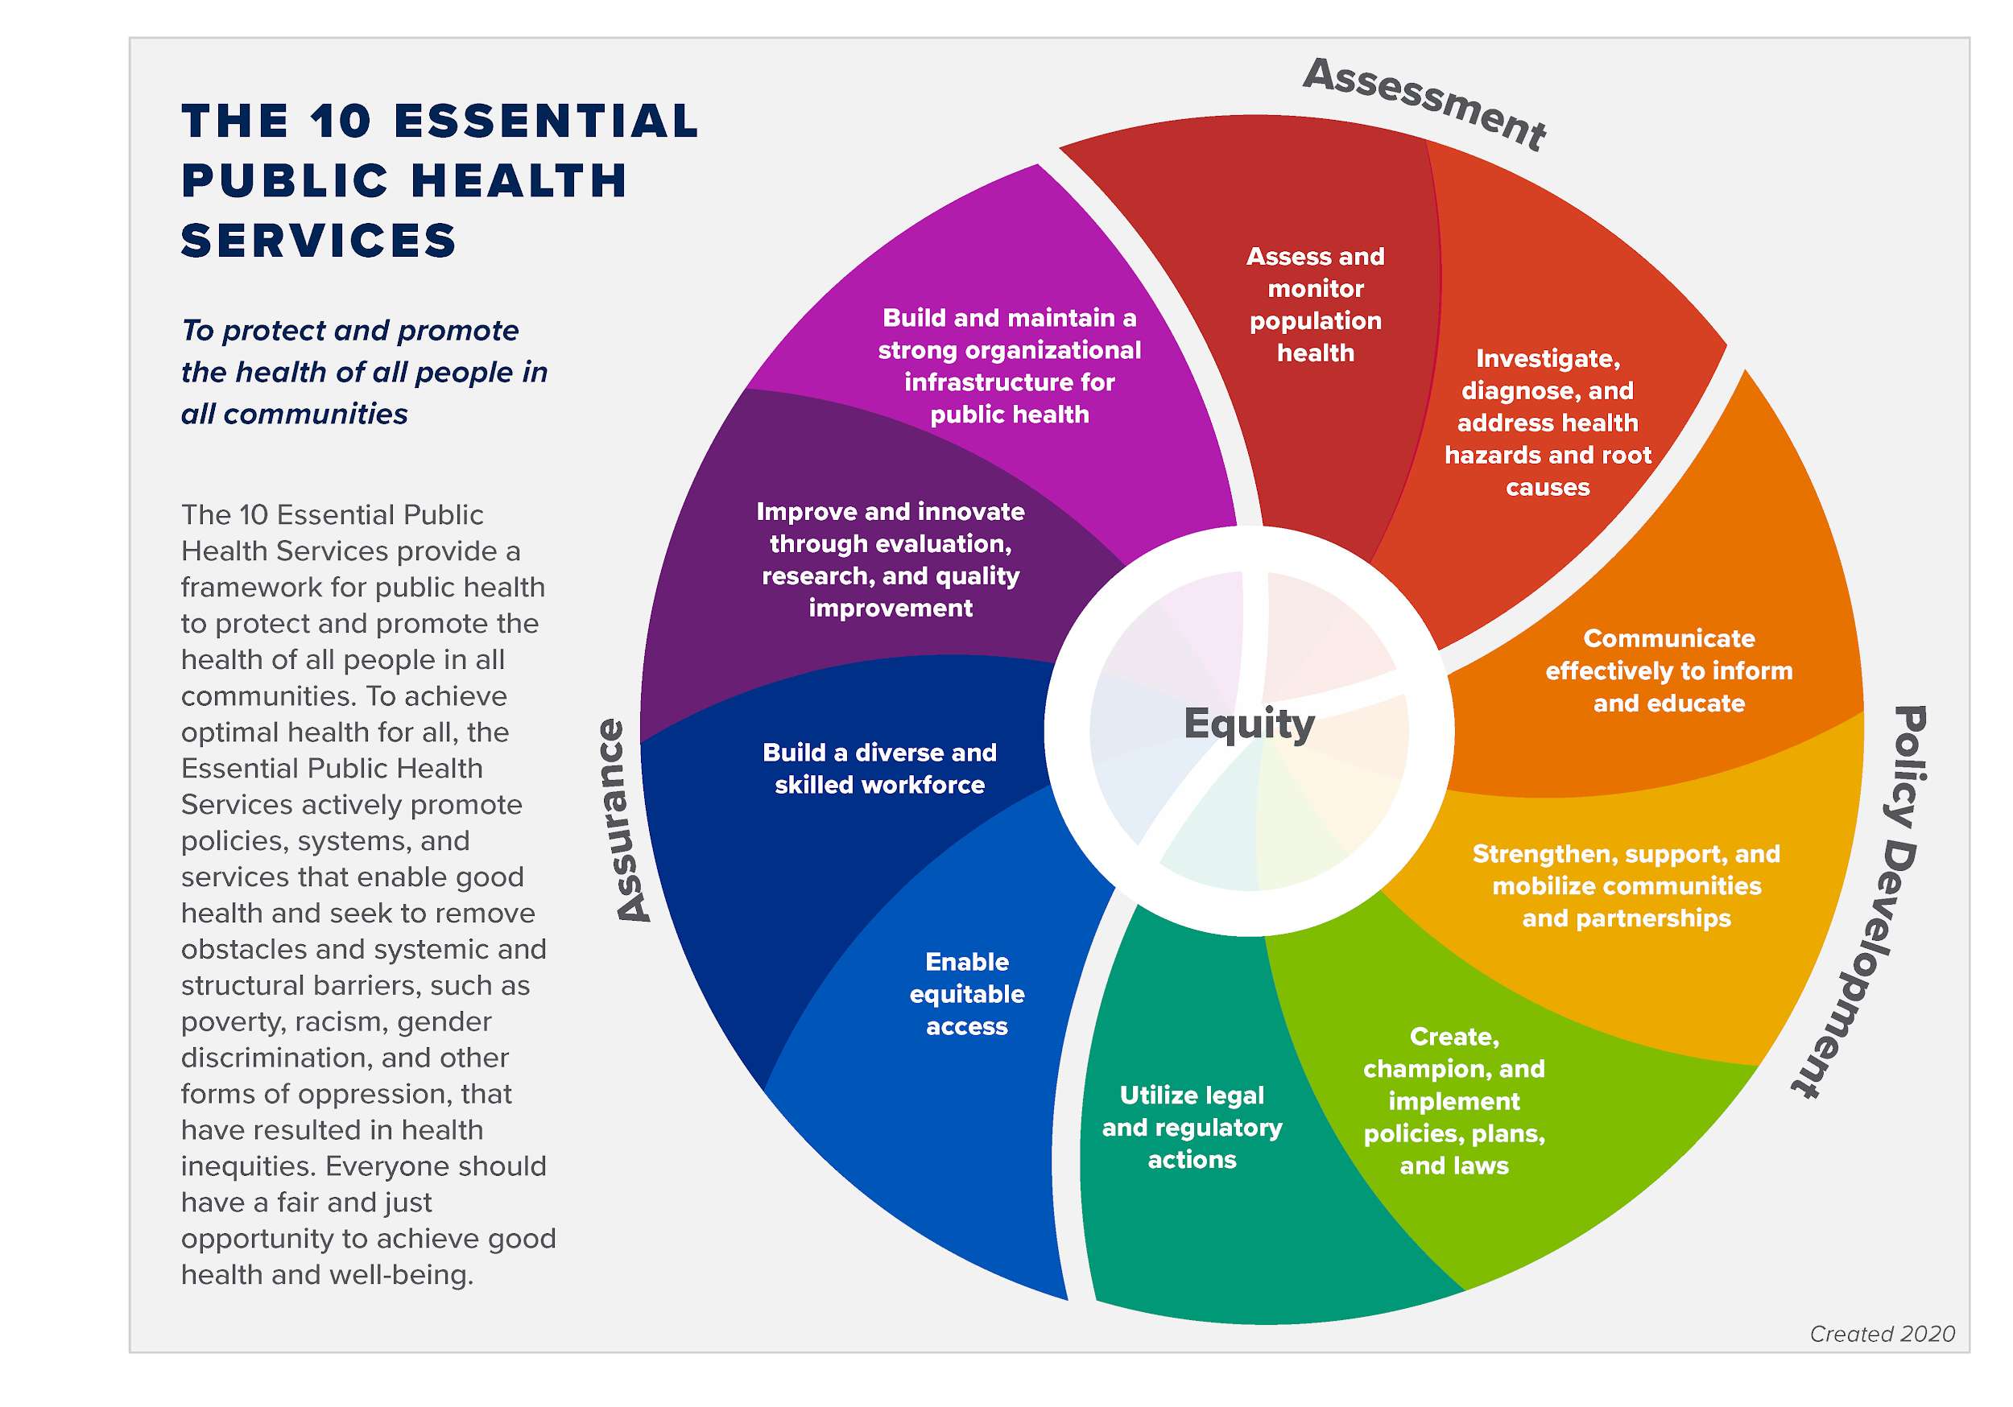

Public Health Services

Keeping you informed

To keep residents informed about COVID and other public health information, we have multiple social media sites and a webpage that have current and relative information.
Stay up to date by visiting the following.

https://www.facebook.com/lafayettecountyhealthdepartment

https://www.instagram.com/lafayettecountyhd.608/

https://twitter.com/LafayettePHNerd

https://www.lafayettecountywi.org/healthdepartment

Health for everyone

The Lafayette County Health Department values all individuals and populations equally. We focus efforts to address inequalities and promote optimal health for all.

Communicable Disease Reporting and Investigation:

According to Wisconsin State Statute Chapter 252, local health departments are responsible for investigating certain communicable diseases. The Lafayette County Health Department investigates communicable diseases reported to us by area hospitals, clinics, schools, long term care facilities, and other reporting sources. We offer education and materials regarding communicable disease and prevention. We also offer tuberculosis screening, treatment and follow up care as needed. Below are the number of reports we have received on certain reportable diseases/infections.

Reportable Disease | Total number of incidents reported | Confirmed Cases | Probable Cases | Suspect Cases
BLASTOMYCOSIS | 1
CAMPYLOBACTERIOSIS | 12 | 11 | 1
CARBAPENEMASE PRODUCING CARBAPENEM-RESISTANT ENTEROBACTERALES | 2
CARBAPENEMASE PRODUCING ORGANISM (CPO) | 1
CARBON MONOXIDE POISONING | 2 | 2
CHLAMYDIA TRACHOMATIS | 54 | 54
CORONAVIRUS, NOVEL 2019 (COVID-19) | 4,676 | 1,381 | 260 | 13
CRYPTOSPORIDIOSIS | 8 | 8
E-COLI, ENTEROPATHOGENIC (EPEC) | 8 | 6 | 2
E-COLI, ENTEROTOXIGENIC (ETEC) | 4 | 4
E-COLI, SHIGA TOXIN-PRODUCING (STEC) | 5 | 5
ENTERIC- NON REPORTABLE | 1
GIARDIASIS | 4 | 4
GONORRHEA | 4 | 2
HAEMOPHILUS INFLUENZAE, INVASIVE DISEASE | 2 | 1
HEPATITIS B, CHRONIC | 16 |  | 1
HEPATITIS C, CHRONIC | 16 |  | 1
HEPATITIS C, PERINATAL | 1
HISTOPLASMOSIS | 1 |  |  | 1
INFLUENZA-ASSOCIATED HOSPITALIZATION | 87 | 4
LYME LABORATORY REPORT | 16 |  | 7 | 6
NON REPORTABLE DISEASE | 2
PARAPERTUSSIS | 6 | 3
PERTUSSIS (Whooping cough) | 29
PESTICIDE RELATED ILLNESS | 1
Q FEVER, ACUTE | 2 | 1 | 1
Q FEVER, ANIMAL REPORT | 3 | 3
Q FEVER, CHRONIC | 1 | 1
Q FEVER, UNSPECIFIED | 1
SALMONELLOSIS | 3 | 3
STREPTOCOCCAL DISEASE, INVASIVE, GROUP A | 1 | 1
STREPTOCOCCAL DISEASE, INVASIVE, GROUP B | 1 | 1
STREPTOCOCCUS PNEUMONIAE, INVASIVE DISEASE | 1 | 1
SYPHILIS REACTOR (FOLLOW UP PERFORMED BY DHS) | 2 |  |  | 1
TUBERCULOSIS | 3
TUBERCULOSIS, LATENT INFECTION (LTBI) | 4 | 1
VARICELLA (CHICKENPOX) | 3 |  | 1
YERSINIOSIS | 2 | 1 | 1

Environmental Health

Our Environmental Health programs provide community outreach and education on environmental health issues. The following areas are handled within our Department:

- Air Quality- Radon test kits are available at our office. Radon test kits are free and provided to Lafayette County Residents.
- Water Quality- Water testing is available through our office. There is a charge for testing with the exception of kits provided to households with pregnant women or with a child under one year of age.
- Human Health Hazards- Investigations may take place to make sure that our residents are living in safe conditions.
- Mosquito & Arboviral Control- Education on prevention and treatment are available.
- Asbestos & Mold- Educational materials are available.
- Any type of inspection is based on the environmentalists' expertise.
- Lead Hazards- Educational materials are available. Inspections are done when warranted.
- Public Health Nuisance- Investigates and addresses public health nuisances, and enforces the public health nuisance ordinance.
- Flood Safety- Educational materials and clean up kits available.

Environmental health contacts and visits made by our Environmental Health Consultant, Troy Moris in 2022:

Environmental Concern | Number of Contacts | Number of Home/Site Visits
Lead | 12
Radon | 27 | 1
Water | 13
Asbestos | 18
Solid waste | 39 | 8
Air Quality | 32 | 1
Sewer | 17
Animal | 12
Housing | 39 | 12
Food |  | 1
Fit Testing |  | 3
Total | 209 | 26

Childhood Lead Testing

Our Public Health Nurses conduct lead testing and follow-up including phone calls, home visits, education, consultation with the child’s health provider. A home risk assessment is conducted if levels are 5 or greater as this level is considered “lead poisoning” and can impact a child’s health. A home visit is performed by our environmental health care consultant and a nurse for lead levels 10 and over. The number of lead tests in our county increased from 81 last year to 113 total this year (from all health care providers).

Number of lead tests below 5 mcg/dl | 109
Lead tests over 5 mcg/dl | 4
Total Lead tests: | 113
Home Investigations | 0

Rabies Prevention

The Lafayette County Health Department receives reports of animal bites or exposures primarily through local law enforcement agencies, veterinarians and residents. According to the Wisconsin State Statute 95.21 local health departments are required to investigate reported bites. We did not have any positive tests for rabies in 2022. The number of animal bites/exposures are included in the table below:
Dog | 34
Cat | 11
Bat Exposures | 4
Bat sent to state Lab | 4
Other animal exposures | 2

Immunization for Children and Adults
Our Department offers vaccines for adults and children through the federal VFC (Vaccine For Children) and VFA (Vaccine For Adults) programs. In 2022, LCHD gave 2,191 shots to 1,616 individuals

Immunization Program Highlights:

- Continued to offer COVID-19 vaccines for adults and children
- Partnered with community agencies for childhood and COVID-19 vaccination clinics, including dental and car seat checks.
- Provided clinics with extended hours for COVID, flu and childhood immunizations
- Provided Flu vaccination clinics at schools
- Provided COVID-19 vaccines at the Lafayette County Jail and several area long term health facilities
- Worked with Memorial Hospital of Lafayette County and Clinics to coordinate COVID-19 booster vaccinations and clinics

Our 2022 Benchmark Goal:
By December 31, 2022, 56% of the children residing in the Lafayette County Health Department (LCHD) jurisdiction who turn 24 months of age during the contract year will have received 4 DTaP, 3 Polio, 1 MMR, 3 Hib, 3 Hepatitis B, 1 Varicella, and 4 Pneumococcal Conjugate (PCR) vaccinations by their second birthday.
We met our Goal with 58% of children who turned 24 months of age during 2022 were up to date with the above vaccines. That percentage increased to 66% when we count children who were over 24 months of age when they completed the vaccination series.

- 2022 Benchmark Report for Children 24 months & under: Total Clients: 257
- Clients that met all benchmark criteria: 150 (58%)
- Late up-to-date clients: 169 (66%)
- Amish Clients: 77 (30%)

Our 2021 Benchmark Goal:

By December 31, 2021 56% of the children residing in the Lafayette County Health Department jurisdiction who turn 24 months of age during the contract year will have received 4 DTaP, 3 Polio, 1 MMR, 3 Hib, 3 Hepatitis B, 1 Varicella, and 4 Pneumococcal Conjugate (PCR) (4313314 series) vaccinations by their second birthday.

In comparison to 2021:
- Our immunization percentages increased from 2021
- 2021 Benchmark Report for Children 24 months & under: Total Clients:231
- Clients that met all benchmark criteria: 111 (48%)
- Late up-to-date clients: 128 (55%)
- Amish Clients: 69 (30%)

Women, Infants and Children Program (WIC)

The WIC program is a nutrition program for women who are pregnant, breastfeeding or postpartum: infants and children younger than 5. WIC provides nutrition education, breastfeeding education and support, supplemental nutritious foods, and connections to other community services.

The Lafayette County Health Department does not provide the WIC program, but refers clients to the program. Prior to COVID-19, SWCAP was coming to our building to provide this service. For the WIC program, Lafayette County had an unduplicated count of 344 women, infants, and children in 2022. This is an increase from 278 women, infants and children served in 2021.

Wisconsin Well Woman Program (WWWP)

The WWWP provides preventive health screenings such as mammograms and cervical screening tests to women with little or no health insurance coverage. The program is administered through Juneau County. Additionally, women who are enrolled in the WWWP program and are found to have breast or cervical cancer are eligible to be enrolled in WWWP Medical Assistance so that their treatment is covered.

WWWP Screening numbers for Lafayette County
Lafayette County Residents enrolled: 55
New Enrollments 2022- 8
Lafayette County residents screened: 26
Lafayette County residents enrolled in WWWP Medical Assistance- 2

Covid Testing

The Lafayette County Health Department offered free COVID-19 community testing. The health department performed 166 COVID-19 tests. Participants were asked to register online using COVID Connect, a registration program through the State Department of Health Services. LCHD staff provided assistance for participants who could not or had difficulty registering. Lafayette County was able to distribute COVID antigen tests for at home testing. We also were able to distribute 1,045 at home COVID test kits to residents through our office and teaming up with community partners.

School Nursing Services

The Lafayette County Health Department provides school nursing services to six schools in the County. This service is contracted individually with each school. Our Public health Nurses (PHN) play a crucial role in student’s health care needs at school, home and in the community. School nurses promote student’s health and safety, intervene with actual and potential health problems, provide case management services and provide training as needed to school staff. School nurses actively collaborate with other partners to build a student’s and their family’s capacity for self-management, self-advocacy and learning.

School nursing services provided include:

- Immunizations
- Vision and Hearing Screening
- Vision, health and dental referrals
- Assistance obtaining care for families without insurance
- Education and planning around student health needs
- Employee health
- Lice screening and follow-up
- Communicable Disease follow-up
- Emergency Nursing Services
- Human Growth & Development education
- Blood Borne pathogen education and training

Lafayette County Human Services Nursing

The Lafayette County Health Department (LCHD) nursing staff provide medication and disease management services for residents of Lafayette County who suffer from chronic mental illness. These services Public Health Nurses (PHN) provide medication management and skilled nursing services through Lafayette County Human Services Department programming in an ongoing collaboration to serve the needs of Lafayette County residents affected by mental illness.

During 2022, PHNs assisted 20 county residents in the Community Support Program (CSP) and 14 county residents in the Comprehensive Community Service (CCS) Program. These services include medication and health management, which enables these individuals to live more full and independent lives. Throughout 2022, there were a total of 705 client contacts made among the 34 clients involved in CCS and CSP. The implementation of COVID-19 restrictions coupled with the Health Department’s effort to protect the population of Lafayette County, PHNs traveled to patients’ homes in an effort to minimize patient’s exposure to COVID-19. To ensure collaborative wrap- around care, PHNs meet with CCS and CSP case managers and psychiatric providers weekly in addition to completing one-on-one patient education and skilled nursing assessments in the mental health clinic. PHNs play an integral role in patient care by acting as a clinical liaison between the patient and their mental and/or medical health care providers.

In addition to the services provided in the community based programs at Human Services, PHNs also assist with case management of patients who participate in Outpatient Mental Health Services, Alcohol and Other Drug Abuse Services, and Emergency Mental Health Services. PHNs also assist with drug test sampling for Family Services Unit cases.

Sharps Program

Lafayette County Health Department offers a free sharps container and disposal program. This program offers a safe way for residents to dispose of sharps containers.

Loan Closet

Our Department offers a loan program for gently used walkers, wheelchairs and other small durable medical equipment. This program is funded through donations from residents and healthcare agencies in the County. We ask for a small donation for any equipment that is borrowed and we accept gently used walkers and wheelchairs for this program.

FREE Water Kits

If a pregnant person or baby under 12 months old in Lafayette County lives in a home with a private well, water test kits for the private well are available for free at the Health Department. Partnering with the WI State Lab of Hygiene helps to ensure a safe water supply for Lafayette County families. Ten kits were sent into the lab in 2022.

Water Quality Program and Bacteria Lab

Lafayette County Health Department recommends that all wells used for drinking water be tested annually for safety. In 2019, the Department became DATCP Certified Water Testing Laboratory for Bacteria (total coliform). In addition to the lab, our Department offers private well water testing kits along with educational materials and techniques that allows residents of the County to properly test and monitor their own well water.

The number of tests performed are below.
Sample Type | Number of Samples
Bacteria- Absent | 147
Bacteria- Present | 10
Bacteria testing total | 157
E. Coli Absent | 156
E. Coli Present | 1
Nitrate | 51
Iron | 1
Arsenic | 3
Total Tests | 369

TNC (Transient Non-Community) Water Systems

The Federal Safe Drinking Water Act (SDWA) governs public water systems. The WI DNR contracts with Lafayette County Health Department (LCHD) to ensure safe drinking water at all public water establishments in Lafayette County.

A transient non-community water system (TN or TNCWS) is a public water system serving at least 25 people at least 60 days of the year, but not the same 25 people over 6 months. Examples of TNs include churches, seasonal campgrounds, gas stations, restaurants, motels, public restrooms and taverns.

Annual site inspections are conducted by the Health Department to identify whether a water system’s components and facility’s system of operation complies with state administrative codes and requirements. Corrective action is required when deficiencies are identified. The Health Department also collects the required Bacteria and Nitrate water samples for public water system owners.

Public Drinking Water Data website – Historical sampling results and other water system information can be found here. (https://dnr.wi.gov/dwsviewer/DS/Search)

Inventoried Transient Non-Community Water Systems | 25
Annual Site Visits | 23
Additional Nitrates | 4
Additional Bacterial | 6
Seasonal Sites | 5
Follow Ups | 0
Level 2 Visits | 0
Sanitary Site Surveys | 2

Public Health Preparedness and Response
The Public Health Emergency Preparedness (PHEP) Program focuses on preparing for, and responding to, events that pose a substantial risk to the health of county residents.
Our purpose is to provide information, resources, and expertise to our partners and community to prepare Lafayette County for health threats, emergencies, and disasters.

State and federal grant dollars fund our PHEP Program. LCHD continues to build and strengthen emergency preparedness and response capabilities to effectively respond to public health threats including infectious diseases, natural disasters, and other events.

Preparedness and Response Capabilities include:

- Community Preparedness
- Community Recovery
- Emergency Operations Coordination
- Information Sharing
- Medical Countermeasures Dispensing and Administration
- Public Health Surveillance and Epidemiologic Investigation
- Responder Safety and Health
- Volunteer Management
- Updates to Communication Plans and contact lists for state and regional stakeholders
- Rapid mobilization and collaborations with health systems, partners and stakeholders to achieve broad vaccination coverage of COVID-19 vaccine in a safe and timely manner
- Compliance with epidemiological investigation protocols and case management in the Wisconsin Electronic Disease Surveillance System (WEDSS) per Wisconsin Administrative Code Ch. DHS145
- Serving as a community resource for information, consultations, public health surveillance and epidemiologic investigations
- Provision of COVID-19 vaccinations to protect and support incident responders
- Utilization of the Wisconsin Emergency Assistance Volunteer Registry (WEAVR) to conduct an alerting drill for volunteer preparedness and quality assurance
The overall goal of the LCHD’s PHEP Program is to help Lafayette County prepare for, respond to, and recover from a disaster as quickly as possible. LCHD and our community partners collaborate to ensure our community is safer, healthier, and more resilient.

In order to build and maintain these capabilities, LCHD implemented the following in 2022:

- Professional development opportunities (e.g., preparedness conferences, ICS and NIMS trainings)
- Emergency drills and tabletop exercises for agency preparedness
- Collaborations with local, regional and state partners
- Participation in the South Central Wisconsin Healthcare Emergency Readiness Coalition (SCWIHERC)
- Collaboration with SCWIHERC to update the Health Vulnerability Assessment (HVA) and participation in regional HVA processes
- Development of After-Action Reports using Homeland Security Evaluation Program

Regional and Local Participation and Collaboration

- Southwest Alliance for Tobacco Prevention
- Mental Health Matters Lafayette County
- Community Connections Free Clinic
- Lafayette County Highway Safety Committee
- Lafayette County Emergency Preparedness Task Force
- Maternal Child Health
- Lafayette County Rural Safety Coalition
- Neighbors and Amigos Council
- Wisconsin Association of Local Health Departments and Boards
- National Association of School Nurses
- Wisconsin Public Health Association
- South Central Wisconsin Healthcare Emergency Readiness Coalition
- Wisconsin Department of Natural Resources
- Wisconsin State Lab of Hygiene
- Environmental Research and Innovation Center- UW-Oshkosh
- Environmental Health Consortium with the Grant, Vernon, Richland and Iowa County Health Departments
- Head Start Advisory Council

